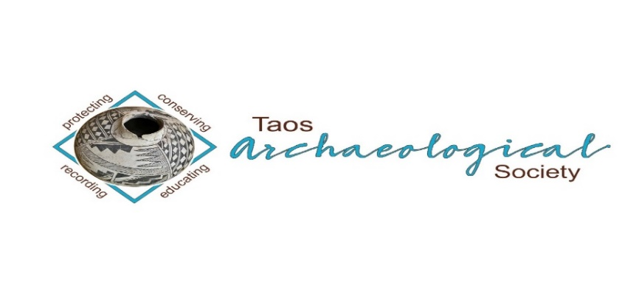
The Taos Archaeological Society

SUMMER BULLETIN SEPTEMBER 2022

WELCOME BACK TO IN PERSON LECTURES. FIRST TALK SEPTEMBER 5, 2022 AT THE KIT CARSON ELECTRIC COOP BOARD ROOM 7pm.
PLEASE BE VACCINATED AND BOOSTED FOR THE HEALTH AND SAFETY OF THE GROUP.
Zoom Meetings are suspended until health and safety protocols require us to return to online lectures

Next Speaker
Paul Reed
Monday September 5, 2022
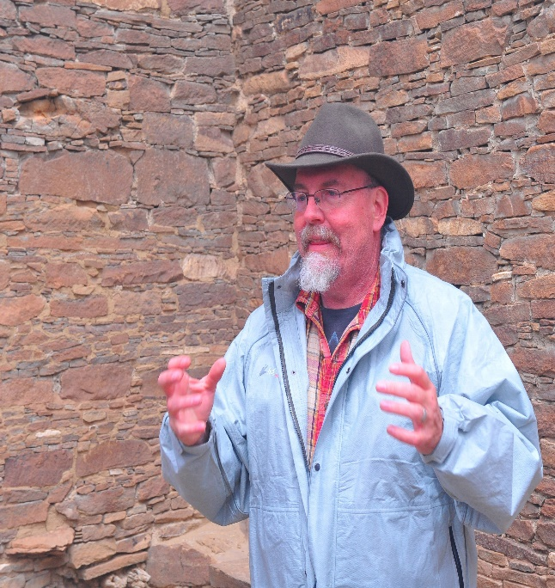
Paul Reed has been a Preservation Archaeologist with Archaeology Southwest since 2001. He is based in Taos, New Mexico and still works as the occasional Chaco Scholar at Salmon Ruins, New. Reed’s most recent writing is an edited book (with Gary M. Brown as co-editor) entitled Aztec, Salmon, and the Pueblo Heartland of the Middle San Juan, published in SAR Press’ Popular Series in 2018. He also served as editor (and author of several chapters) on Chaco's Northern Prodigies: Salmon, Aztec, and the Ascendancy of the Middle San Juan Region After AD 1100, published by the University of Utah Press (2008). Reed was also editor (and author of several chapters) of the three-volume, comprehensive report entitled Thirty-Five Years of Archaeological Research at Salmon Ruins, New Mexico published in 2006. His other books – The Puebloan Society of Chaco Canyon (2004) and Foundations of Anasazi Culture (published in 2000; as editor and author) have explored the origins of Puebloan culture and Chaco Canyon.
During the last six years, Reed has been working to protect the Greater Chaco Landscape from the effects of expanded oil-gas development associated with fracking in the Mancos Shale formation. Through a series of meetings and forums with public officials, Tribal leaders, various US Government agencies, and New Mexico’s Congressional delegation, Archaeology Southwest and its partners have focused on expanding protections to sites, traditional cultural places, and fragile landscapes in the greater San Juan Basin. The most recent effort on this front is to partner with the Pueblo of Acoma to complete a focused ethnographic study of Acoma’s connections to the Greater Chaco Landscape.
Among his other interests, Reed leads tours to Salmon and Aztec Ruins, Chaco Canyon, the Chuska Valley, and the Navajo Country, and gives public presentations on different topics in southwestern archaeology and history. Reed has conducted fieldwork and research in the Southwest for more than 30 years. From 1993 to 2001, Reed directed a roads archaeology research program for the Navajo Nation Archaeology Department, Farmington, New Mexico. Reed completed his Bachelor of Arts (1986) and Master of Arts (1989 in anthropology and archaeology) degree at New Mexico State University.

What We’re Doing to Protect Greater Chaco in 2022.
Paul F. Reed

The last year has been very eventful in the battle to protect the Greater Chaco Landscape from the encroachment of oil-gas development. Late last year, Interior Secretary Deb Haaland announced the withdrawal of 351,000 acres of Federal BLM lands from oil-gas leasing in a 10-mile zone around Chaco Canyon and several Chacoan Outliers. This is the culmination of a nearly 10-year process. Other processes are moving forward, as well, including a comprehensive effort by Tribal Nations to understand their connections to the Greater Chaco Landscape. In this presentation, I’ll discuss recent progress and look into the future of Greater Chaco protection.

Taos Archaeological Society Bears Ears Trip
October 6-9, 2022
CONTACT taoscuba@hotmail.com to reserve spots.

Trip Leader: R.E. Burrillo; rburrillo@gmail.com. R.E. Burrillo is an author and archaeologist who has worked in and around Bears Ears for decades.

Cost: $275

Required for participants: 1) active current Member of the Taos Archaeological Society to participate; 2) sign trip waivers; 3) proof of covid vaccination and booster.

Trip Does Not Include: Transportation to Bluff, Utah, meals and extra food, camping gear, backpack, water bottles, sunglasses, sunscreen, rain gear, good hiking boots, and personal first aid.

Itinerary:

Thursday
5 p.m. Meet at Sand Island Group Campsite, near Bluff, Utah
6 p.m. Group dinner out, most likely Twin Rocks in Bluff

Friday
8 a.m. Breakfast. Pack your Lunch.
Daily Briefing Safety and Ethics
Bears Ears Education Center
Have a full tank of gas
11:00 Carpool up Comb Wash, stopping to see hand-and-toe routes on the way
Lunch at Comb Wash Campground (assuming there’s a free picnic table)
Hike into Lower Mule Canyon site
Hike into Arch Canyon site
5:00 return to camp and Happy Hour
6:00 Dinner

Saturday
8 a.m. Breakfast and see Sand Island Rock Art. Pack your lunch.
Daily Briefing Safety and Ethics
Have a full tank of gas
9:00 Carpool up Butler Wash, hike into Double Stack Ruin
Hike into Cold Spring Cave and up to Eagle’s Nest overlook
Lunch someplace en route (folding camp tables)
Hike into Split Level Ruin
Butler Ruin overlook
5:00 return to camp and Happy Hour
6:00 Dinner

Sunday
9 a.m. Breakfast and break camp. Pack your lunch.
Daily Briefing Safety and Ethics
Carpool to Cedar Point to look at rock art, then up the Moqui Dugway to the top of Cedar Mesa and out to Muley Point overlook.
Wrap-up trip and head out by 2pm.

Message for the Members of TAS:

Hope you had a great summer and are all getting vaccinations and boosters so we can begin to have face to face meetings as soon as possible. We begin September 5, 2022 MONDAY to have in person lectures at the Kit Carson Electric Coop Board Room. 7pm -830pm as usual.
Please go to You Tube and Enter Taos Archaeological Society for recorded Lectures you may have missed.

The lectures from ASNM this Spring 2022 are recorded on You Tube.
Search: Archaeological Society of New Mexico Annual Meeting 2022 DAY One, DAY TWO, or DAY THREE.

Until then, stay healthy and safe,

Thank you and we will see you all soon.

The TAS Officers

In August 2022, The Taos Archaeological Society donated $200.00 to the Go Fund me for teacher Rob Bergman. We received the note of thanks from his partner below.
To all my dear friends, family and community who have contributed so generously to this GoFundMe, I would like to express my deepest gratitude. It is incredibly humbling to accept such generosity from you all. I am so grateful to each of you for every contribution toward our family. The funds far exceeded the memorial and funeral costs for our Rob. If I may, I would like to save these funds to help Sundia in the future since there was no life insurance. These are dark times for us, but I trust the grieving process will ease, and in the meantime, I walk through this world from a humble, grateful position in deepest gratitude for your love, support and care.
Thank you all so much,
With love,
Amanda

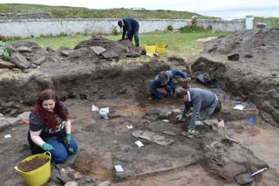

An effort is currently underway to build a historical timeline of events in the history of the Taos Archaeological Society. We need your help if you have records that date in the period September 1999 through February 2014. These dates range between the last completed history for the society and the earliest records archived on our web site.

The Taos Archaeological Society has operated for 34 years. At present documents we have accessible cover under 60 percent of that time. Old bulletins, meeting minutes, financial statements, member lists and other communications of the society will assist in this effort. Please do help if you can. You can send records directly to Paul McGuff (pmcguff@aol.com).

TAS, SMU-Taos and the Picuris Pueblo in Partnership!!!

A New Ceramic Analysis Committee Has been formed!!

Ceramic Sorting and Analysis is getting organized for a pilot project to have analysis conducted on a private take home individual basis to observe Covid-19.

Picuris Analysis Ceramic Sorting is still requesting volunteers to participate in processing out their Prehistoric collections. Contact Mark Henderson for more information. markscotthenderson@gmail.com

Sherder’s ZOOM MEETINGS temporarily suspended.

Zoom Id Number Meeting ID: 878 3989 2686

Taos Black on White
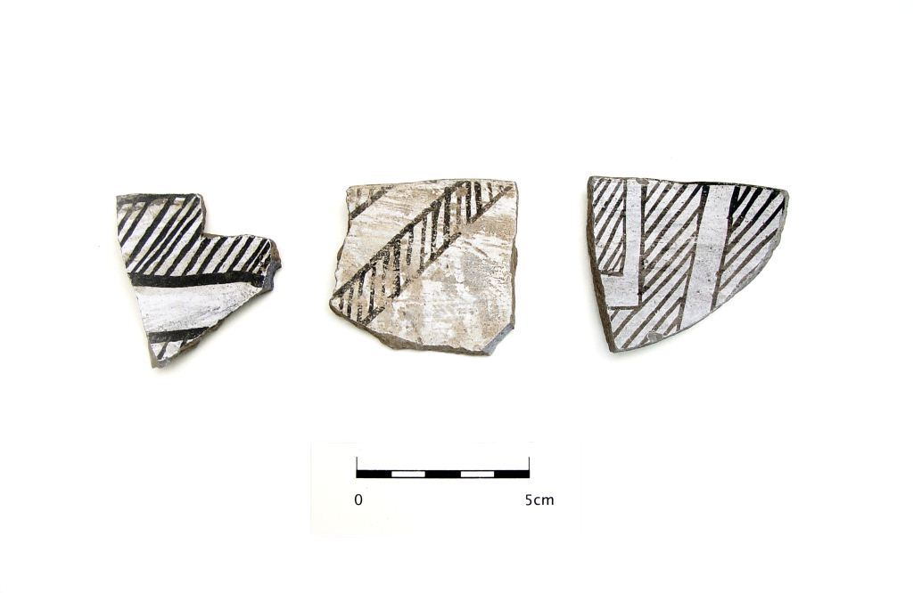
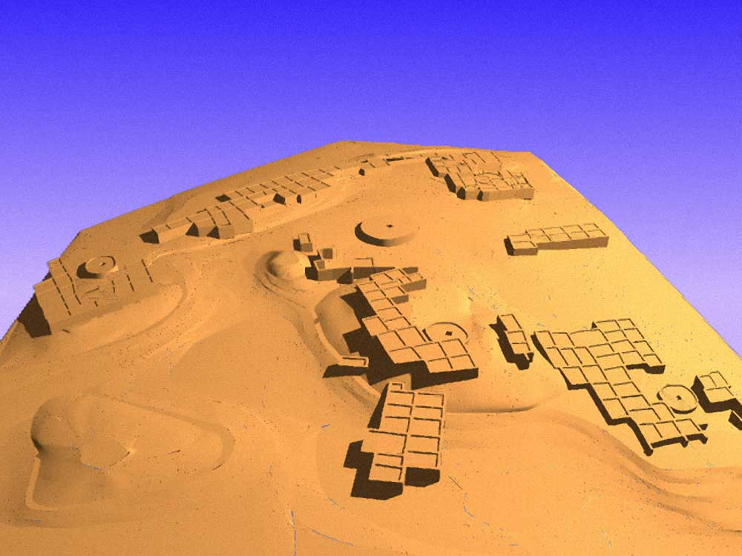

Pot Creek Pueblo 1320 AD

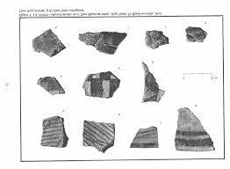
Slate of TAS Officer Elected for 2022-2023
February 1, 2022 until January 31, 2023

Phil Alldritt President
Cassandra Keyes Vice President
Debbie Espie Secretary
Chris Ellis Treasurer

Webmaster (Non Officer position)
Phil Alldritt

The Current Committee Chairs Are as follows:

Education Committee Anita Briscoe

Fieldwork Committee Gary Grief

Newman Dome Subcommittee Cassandra Keyes

Picuris Ceramic Analysis Committee Mark Henderson

Blumenshein Ceramic Analysis Committee For Charter Development
Kurt Weidler/ Jeff Boyer/Becky Quintana/Paul McGuff

Program Committee Cassandra Keyes, Debbie Dean, Phil Alldritt

Trip Committee Paul Reed , Phil Alldrit

Lifetime memberships are possible anytime for TAS. For $500.00 you will receive Lifetime membership plus 1. This can be a spouse or partner. Contact tasorg@hotmail.com if interested. Thank you!

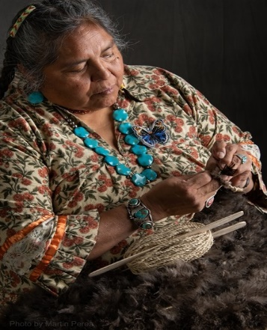
THIS ACTIVITY Has Been Rescheduled for Saturday JUNE 10, 2023
Members already paid are signed up!!!

To the Membership of the Taos Archaeological Society,

On Saturday, June 10, 2023, Mary Motah will conduct a basket and sandal weaving demonstration and hands on workshop for TAS members. The workshop will take place at the Kit Carson Board Room on Cruz Alta Road from 10am-4pm.

The participation is limited to 15 persons. This will fill quickly. Registration based on first 15 payments received. Please include your email to receive a confirmation.

If you miss out we will do this in an ongoing basis. The second 15 payments received will be confirmed to participate in the June 2023 workshop.

The participation fee is $15.00 check or money order made out to Mary Motah. It should be mailed to

Phil Alldritt
PO Box 659
Arroyo Hondo, NM 87513

First 15 deposits received are confirmed. No one is confirmed until payment is received.

Participants should bring a small pocket knife, wear shorts, bring brownbag lunch and drink.

In case of cancellation and you request a refund contact me here.

Thank you for your support and participation in the TAS activities!!

July 31 we had a great turnout for the summer pot luck. More than 60 showed up. Thank you to John and Janet Mockovciak for hosting the party and thanks to Jimmy Stadler for the Great Music!!

WINTER 2022 SUMMER POT LUCK
MONDAY December 5, 2022
Watch your email for further information.

TAKING RESERVATIONS FOR
FALL 2022 and SPRING 2023!!!!!
The Taos Archaeological Society is Funding trips for students to The Mesa Prieta Petroglyph Project!! Trips coming up in Fall 2022 and Spring 2023!!! COVID PERMITTING!!!
Contact Phil Alldritt at taoscuba@hotmail.com

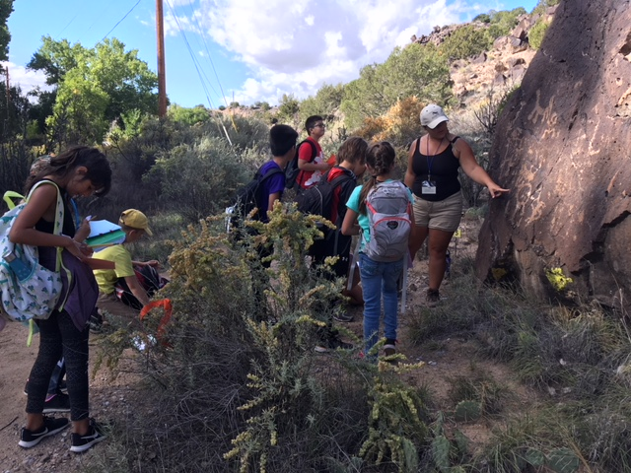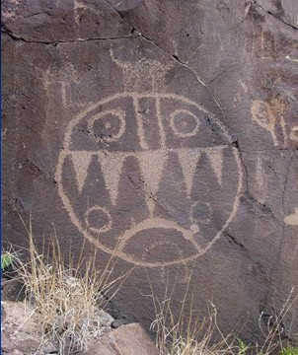

TAS is looking for Members to form an Education Committee who will promote and facilitate communication with teachers and schools to advance our bus trip programs!! To participate in this very successful effort contact Phil Alldritt at taoscuba@hotmail.com
Thank you!!!

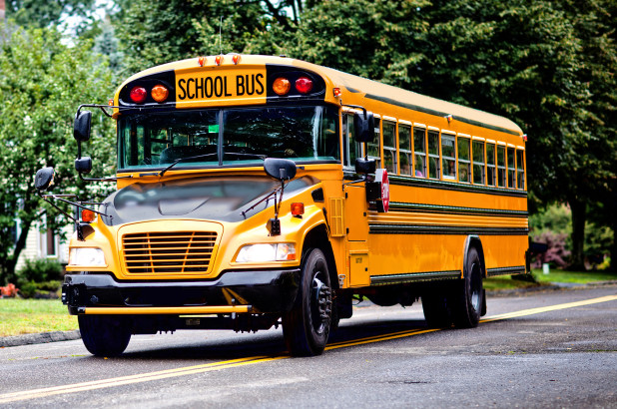

Upcoming Trips
Trip reservations are first come first serve all trips have limited space. No reservation is confirmed until deposits have been made. Watch for future trips on the website!!!
Thank you! COVID PERMITTING!!!
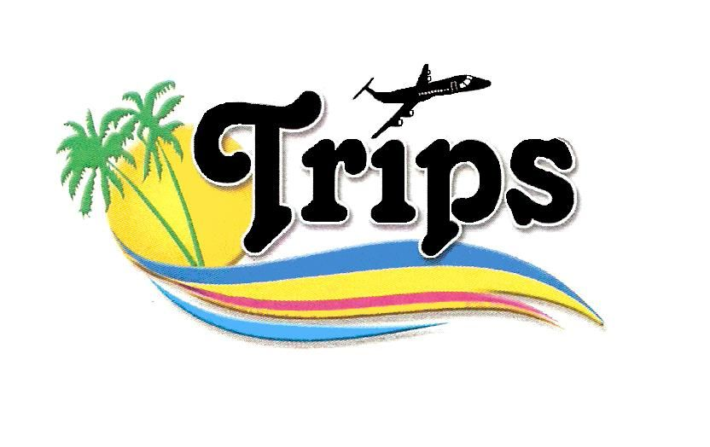All TAS trips may be sign up for by TAS Members who are Active Members in Good Standing. Persons wanting to participate should become Members by mailing 30.00 to
TAS PO Box 143 Taos, NM 87571 Thank you.

Next Speaker
Michael Burney
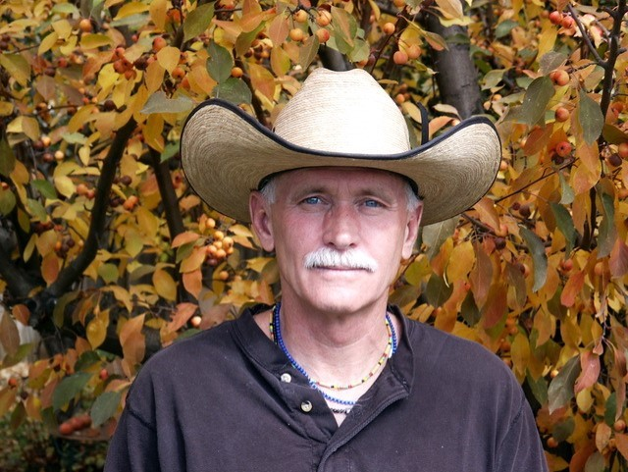
October 3, 2022
My Bio:

My career as an applied archaeologist began in 1975, while residing in Boulder, Colorado. Before relocating to Taos in 1997, I participated in numerous archaeological projects throughout the western United States. Unfortunately, not one of these projects had the benefit of Native participation. That is, until 1987, when I was hired in Denver, by the Council of Energy Resource Tribes (CERT) to establish a tribal archaeological contracting program for the Confederated Tribes of the Umatilla Indian Reservation (CTUIR) in Pendleton, Oregon. Finally, after 12 years as a contracting archaeologist, I had the unique, and long overdue, opportunity of working with indigenous people in American archaeology. Since that time, I've had the honor of working with many tribes, including: Tribal Archaeologist for the Rosebud Sioux and Yankton Sioux of South Dakota; and, the Ft. Peck Assiniboine and Sioux tribes and Northern Cheyenne Tribe of Montana. I continue to strongly advocate and support Native involvement in American archaeology. My B.A. in anthropology was awarded by the University of Idaho, Moscow, in 1971. My M.A. in Western American Prehistory was awarded by the University of Colorado, Boulder, in 1991.

Presentation Title:

"Tribal Archaeology is American Archaeology"

Presentation Synopsis:

Historically, American archaeology failed to acknowledge American Indian (Native) ownership of the indigenous "cultural resources" being recorded, evaluated for their "significance," curated in museums, and described in unpublished reports, professional papers, and published articles and books. This glaring omission not only failed archaeology but Native people, as well. However, with the passage of the National Historic Preservation Act of 1966, specifically, amendments enacted in 1980 and 1992, federally recognized tribes, of which there are now 574, slowly began to assume their rightful place in contract archaeology, better known as "cultural resource management." Tribal Historic Preservation Officers (THPOs) have sovereign authority over their tribal cultural resources within the external boundaries of their reservations; in addition to, considerable influence on their historically utilized aboriginal lands. Another significant federal law is the Native American Graves Protection and Repatriation Act of 1990 (NAGPRA) providing much needed protection of Native human remains and associated burial goods.

Exciting speakers coming all next year in 2023!!!! Watch for the bulletins beginning each month online at taosarch.org for announcements!!!!

.

.

