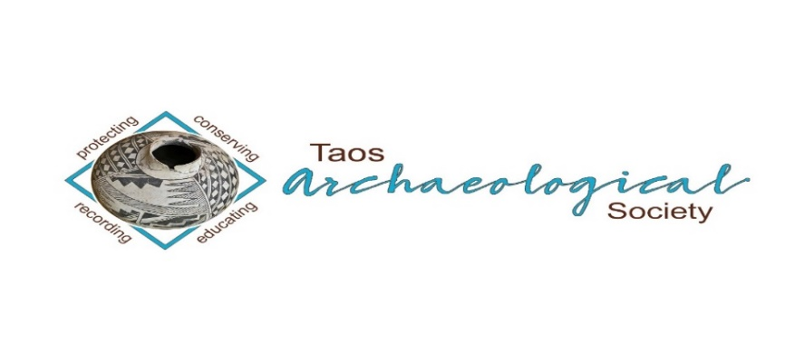
The Taos Archaeological Society

BULLETIN NOVEMBER 2022

WELCOME BACK TO IN PERSON LECTURES. WE MEET AT THE KIT CARSON ELECTRIC COOP ON CRUZ ALTA at 7pm.
PLEASE BE VACCINATED AND BOOSTED FOR THE HEALTH AND SAFETY OF THE GROUP. Feel free to wear a mask according to your comfort level. We recommend this to stay safe from all air born transmission.
The TAS Monthly Lectures are recorded (unless the speaker requests we not record it) and will be available on You Tube three days after the live meeting. Thank you.
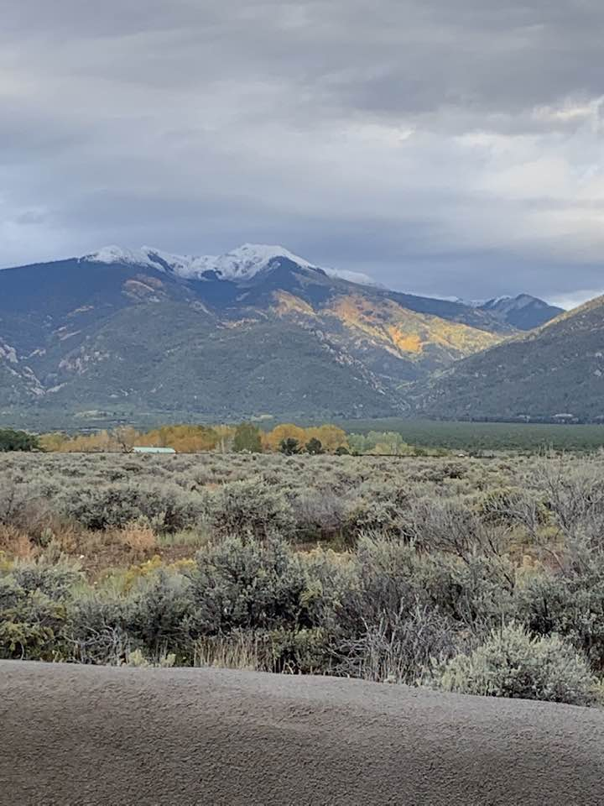
Photo: Christiane Riveles

Next Speaker November 7, 2022
Jonathan Dombrosky

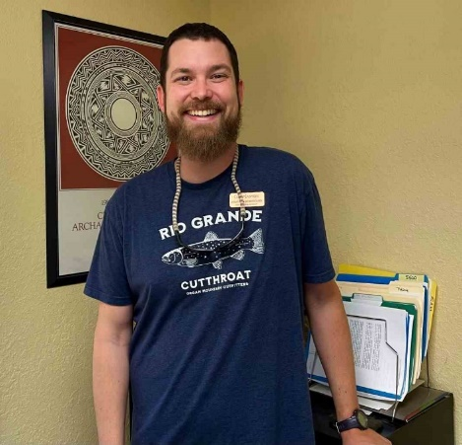

Jonathan is an archaeologist who is broadly interested in human-environment interactions from the past to the present across the globe. He focuses on North American prehistory, specializes in the zooarchaeology of the U.S. Southwest, and uses principles of data science in his research. He received his PhD at the University of New Mexico and is postdoctoral scholar at Crow Canyon Archaeological Center. Jonathan is particularly fascinated by human behavioral ecology, stable isotope ecology, 3D geometric morphometrics, radiocarbon chronology building, and conservation biology.

Title: Down the Rabbit Hole: Testing the Garden Hunting Hypothesis in the Northern U.S. Southwest

Abstract: Garden hunting is the capture of animals from cultivated areas for food, and it is a specific subsistence practice where humans simultaneously use gardens for food production and as animal traps. Here, Jonathan summarizes work where he and a team of researchers use stable isotope analysis to test whether jackrabbits and cottontails fed on the same foods that Ancestral Pueblo people did. He demonstrates how these animals—recovered from the multiple sites—relied on categorically different foods than humans, which raises important questions about the prevalence of garden hunting in the past and what the abundance of jackrabbit and cottontail remains represents. This work highlights the need to more thoroughly understand how farming impacted wild animals in the pre-Hispanic U.S. Southwest, how those impacts altered foraging practices, and how those practices changed or remained constant through time.

ELECTION OF NEW OFFICERS FOR 2023-2024
Nominations for new officers will begin November 1, 2022. We will take nominations for 60 days until January 1, 2023. Then, a thirty-day electronic vote will be held until January 31, 2023. The new officers will be confirmed February 1, 2023. You can nominate an officer at taoscuba@hotmail.com. Thank you.
We are looking for 3 persons with fresh ideas and lots of energy to take over lead positions including President and Treasurer. Treasurer nominee should be familiar with Quik Books. Hopefully, nominees will also be able to commit to a 2-year term of service. Potential nominees can contact us at (taoscuba@hotmail.com) for more information concerning the duties of officers for TAS. The current officers are available to help with the transition next year.
TAS has completed 35 years of volunteer service in the Taos community. It has been an honor to represent the membership during the last 7 years. Thank you.

Message for the Members of TAS:

Hope you had a great summer and are all getting vaccinations and boosters so we can begin to have face to face meetings as soon as possible. We begin September 5, 2022 MONDAY to have in person lectures at the Kit Carson Electric Coop Board Room. 7pm -830pm as usual.
Please go to You Tube and Enter Taos Archaeological Society for recorded Lectures you may have missed.

The lectures from ASNM this Spring 2022 are recorded on You Tube.
Search: Archaeological Society of New Mexico Annual Meeting 2022 DAY One, DAY TWO, or DAY THREE.

Until then, stay healthy and safe,

Thank you and we will see you all soon.

The TAS Officers

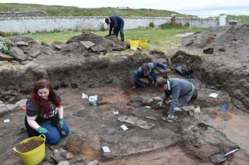

An effort is currently underway to build a historical timeline of events in the history of the Taos Archaeological Society. We need your help if you have records that date in the period September 1999 through February 2014. These dates range between the last completed history for the society and the earliest records archived on our web site.

The Taos Archaeological Society has operated for 34 years. At present documents we have accessible cover under 60 percent of that time. Old bulletins, meeting minutes, financial statements, member lists and other communications of the society will assist in this effort. Please do help if you can. You can send records directly to Paul McGuff (pmcguff@aol.com).

TAS, SMU-Taos and the Picuris Pueblo in Partnership!!!

A New Ceramic Analysis Committee Has been formed!!

Ceramic Sorting and Analysis is getting organized for a pilot project to have analysis conducted on a private take home individual basis to observe Covid-19.

Picuris Analysis Ceramic Sorting is still requesting volunteers to participate in processing out their Prehistoric collections. Contact Mark Henderson for more information. markscotthenderson@gmail.com

Sherder’s ZOOM MEETINGS temporarily suspended.

Zoom Id Number Meeting ID: 878 3989 2686

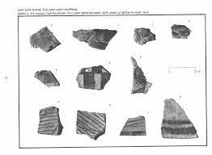

Taos Black on White
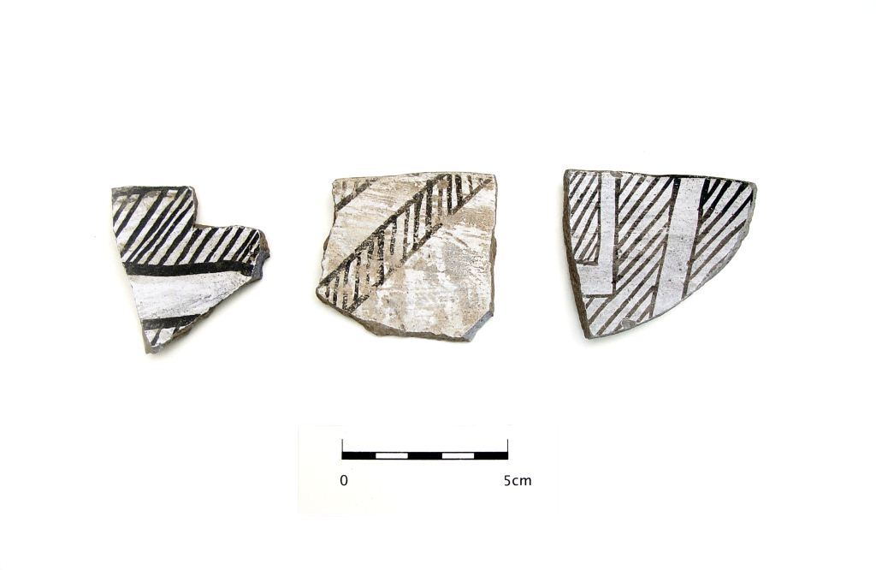
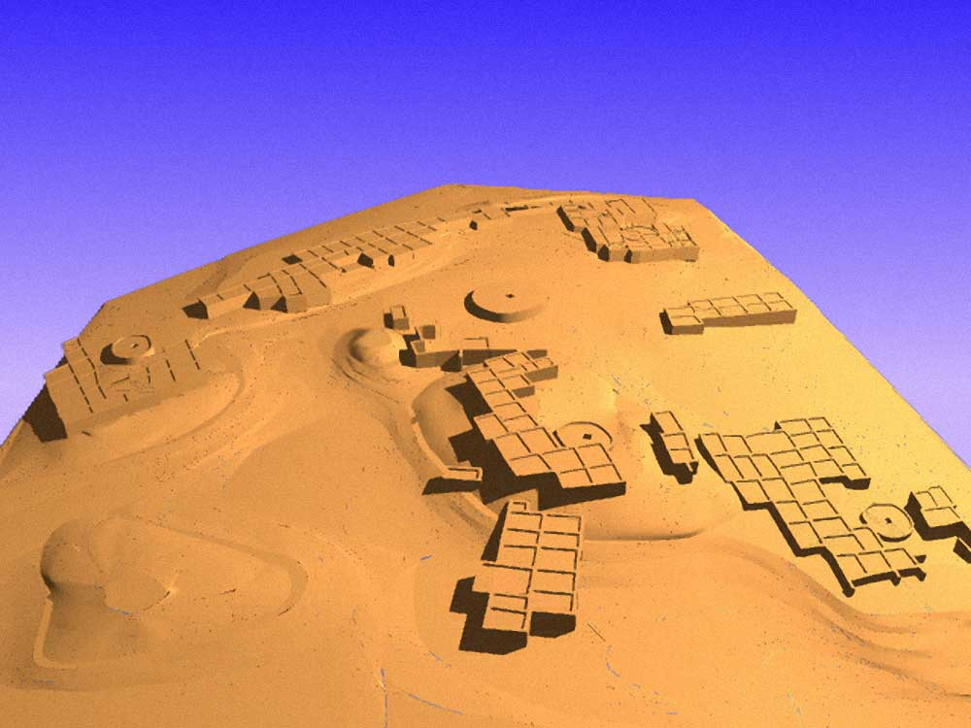

Pot Creek Pueblo 1320 AD

Slate of TAS Officer Elected for 2022-2023
February 1, 2022 until January 31, 2023

Phil Alldritt President
Cassandra Keyes Vice President
Debbie Espie Secretary
Chris Ellis Treasurer

Webmaster (Non Officer position)
Phil Alldritt

The Current Committee Chairs Are as follows:

Education Committee Anita Briscoe

Fieldwork Committee Gary Grief

Newman Dome Subcommittee Cassandra Keyes

Picuris Ceramic Analysis Committee Mark Henderson

Blumenshein Ceramic Analysis Committee For Charter Development
Kurt Weidler/ Jeff Boyer/Becky Quintana/Paul McGuff

Program Committee Cassandra Keyes, Debbie Dean, Phil Alldritt

Trip Committee Paul Reed , Phil Alldrit

Lifetime memberships are possible anytime for TAS. For $500.00 you will receive Lifetime membership plus 1. This can be a spouse or partner. Contact tasorg@hotmail.com if interested. Thank you!
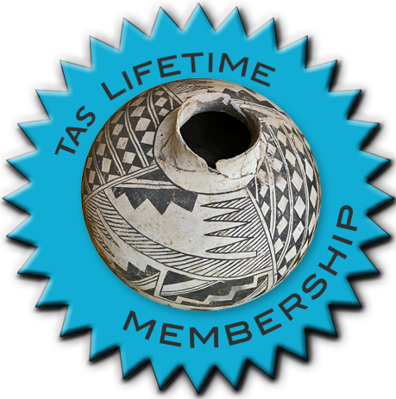

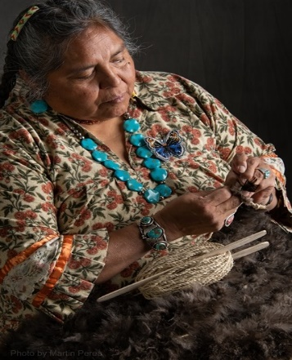
THIS ACTIVITY Has Been Rescheduled for Saturday JUNE 10, 2023
Members already paid are signed up!!!

To the Membership of the Taos Archaeological Society,

On Saturday, June 10, 2023, Mary Motah will conduct a basket and sandal weaving demonstration and hands on workshop for TAS members. The workshop will take place at the Kit Carson Board Room on Cruz Alta Road from 10am-4pm.

The participation is limited to 15 persons. This will fill quickly. Registration based on first 15 payments received. Please include your email to receive a confirmation.

If you miss out we will do this in an ongoing basis. The second 15 payments received will be confirmed to participate in the June 2023 workshop.

The participation fee is $15.00 check or money order made out to Mary Motah. It should be mailed to

Phil Alldritt
PO Box 659
Arroyo Hondo, NM 87513

First 15 deposits received are confirmed. No one is confirmed until payment is received.

Participants should bring a small pocket knife, wear shorts, bring brownbag lunch and drink.

In case of cancellation and you request a refund contact me here.

Thank you for your support and participation in the TAS activities!!

WINTER 2022 SUMMER POT LUCK
MONDAY December 5, 2022
Pot Luck to be held at the Kit Carson Board Room on Cruz Alta Road from 6:15pm-8:15pm.
Dinner promptly served at 6:30pm.
Bring your Favorite dish and your serving spoons please.
Iced Tea, Lemonade and Water will be included.
NO ALCOHOL ALLOWED at this event.
See you there!!!!

TAKING RESERVATIONS FOR
FALL 2022 and SPRING 2023!!!!!
The Taos Archaeological Society is Funding trips for students to The Mesa Prieta Petroglyph Project!! Trips coming up in Spring 2023!!!
Contact Phil Alldritt at taoscuba@hotmail.com

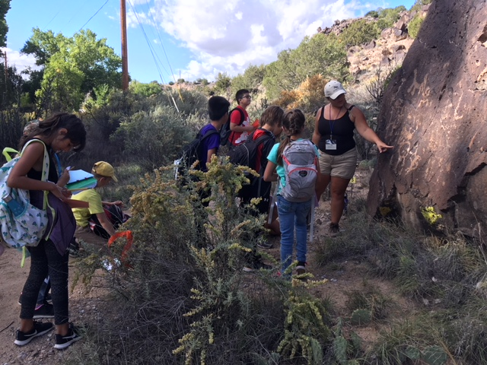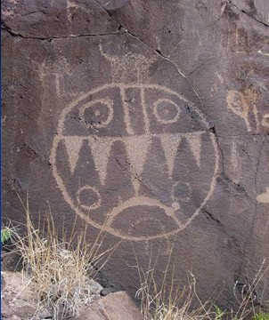

TAS is looking for Members to form an Education Committee who will promote and facilitate communication with teachers and schools to advance our bus trip programs!! To participate in this very successful effort contact Phil Alldritt at taoscuba@hotmail.com
Thank you!!!

Upcoming Trips
Trip reservations are first come first serve all trips have limited space. No reservation is confirmed until deposits have been made. Watch for future trips on the website!!!
Thank you!
All TAS trips may be sign up for by TAS Members who are Active Members in Good Standing. Persons wanting to participate should become Members by mailing 30.00 to
TAS PO Box 143 Taos, NM 87571 Thank you.
NEXT SPEAKER
Monday January 2, 2022
TBD

Exciting speakers coming all next year in 2023!!!! Watch for the bulletins beginning each month online at taosarch.org for announcements!!!!

.

.

