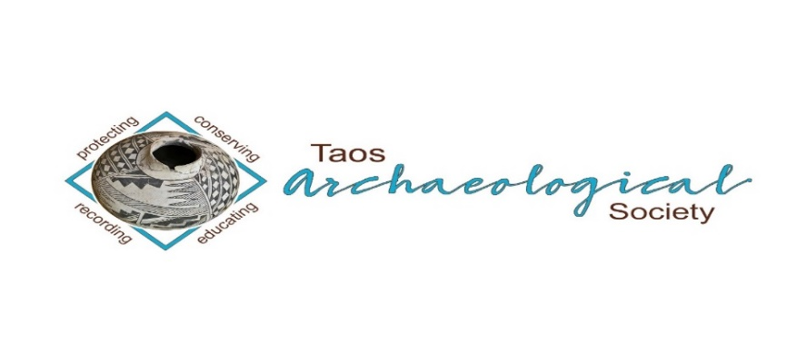

The Taos Archaeological Society
BULLETIN March 2023

Next Speaker
Joseph Birkmann
MONDAY MARCH 6, 2023
Kit Carson Board Room at 7pm.
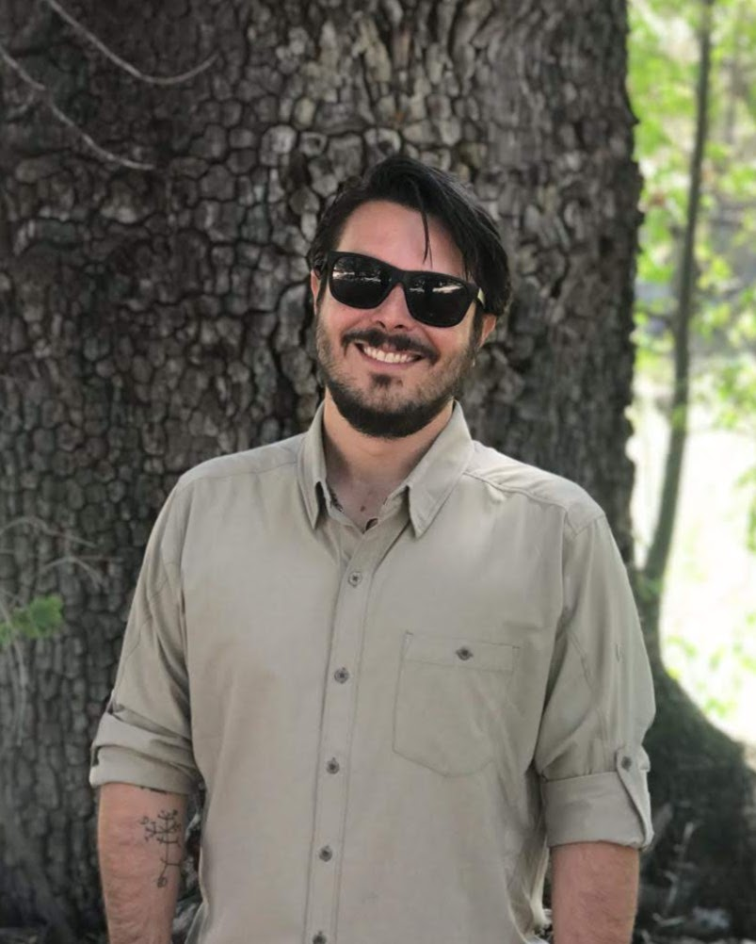
Joseph Birkmann is a Ph.D candidate and archaeologist at the University of New Mexico. focused on the Archaic period archaeology of New Mexico and Arizona. He is a lithicist and geoarchaeologist whose research examines projectile point typology during the Archaic period and the transition to agriculture during the late-Middle Archaic in the Southern Southwest.
Topic
In the early 1940s, Joseph Toulouse Jr., Kirk Bryan, and Bryan McCann published two articles describing the archaeology and geology of seventeen preceramic sites around Grants, NM, defining the preceramic San Jose Complex. George Agogino, Jim Hester, and William Roosa periodically revisited a subset of these sites during the 50s and 60s, publishing three articles and collecting additional artifacts. Despite the importance of these sites to the history of preceramic research in Northern NM, no synthetic history of research or analysis of the projectile point collections has been undertaken to date. In this talk, I provide: 1) brief history of the Grants San Jose collections, 2) an inventory of diagnostic projectile points, 3) an analysis of raw materials represented and geochemical analysis of a sample of obsidian dart points, and 4) a brief discussion of the implications of the collection for the preceramic archaeology of the Grants area.

PLANNED TRIPS FOR 2023
May 2023 Chaco Canyon Trip (Dates TBD)
June 2-3, 2023 Folsom Site Space Available (8)
October 2023 Bears Ears (Dates TBD)

WELCOME BACK TO IN PERSON LECTURES. WE MEET AT THE KIT CARSON ELECTRIC COOP ON CRUZ ALTA at 7pm.
PLEASE BE VACCINATED AND BOOSTED FOR THE HEALTH AND SAFETY OF THE GROUP. Feel free to wear a mask according to your comfort level. We recommend this to stay safe from all air born transmission.
The TAS Monthly Lectures are recorded (unless the speaker requests we not record it) and will be available on You Tube three days after the live meeting.
Please watch your emails as we may move meetings to ZOOM only as Health protocols change or weather becomes an issue. Thank you.

ELECTION OF NEW OFFICERS FOR 2023-2024
The NEW Officers for TAS 2023-2024 are now confirmed.
Philip Alldritt
Cassandra Keyes
Debbie Espie
Chris Ellis

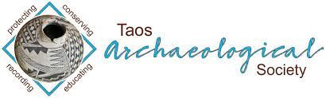

Message for the Members of TAS:

Hope you had Happy Holidays and are all getting vaccinations and boosters so we can ensure the health and safety of those who attend in person lectures.
We begin again with LIVE LECTURES MONDAY February 6, 2023. In person lectures will be at the Kit Carson Electric Coop Board Room. 7pm -830pm as usual.
Please go to You Tube and Enter Taos Archaeological Society for recorded Lectures you may have missed.

The lectures from ASNM this Spring 2022 are recorded on You Tube.
Search: Archaeological Society of New Mexico Annual Meeting 2022 DAY One, DAY TWO, or DAY THREE.

Until then, stay healthy and safe,

Thank you and we will see you all soon.

The TAS Officers

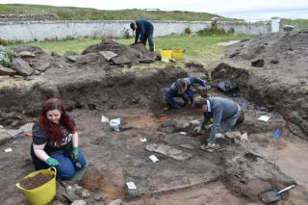

An effort is currently underway to build a historical timeline of events in the history of the Taos Archaeological Society. We need your help if you have records that date in the period September 1999 through February 2014. These dates range between the last completed history for the society and the earliest records archived on our web site.

The Taos Archaeological Society has operated for 35 years. At present documents we have accessible cover under 60 percent of that time. Old bulletins, meeting minutes, financial statements, member lists and other communications of the society will assist in this effort. Please do help if you can. You can send records directly to Paul McGuff (pmcguff@aol.com).

TAS, SMU-Taos and the Picuris Pueblo in Partnership!!!

An update to the Ceramic Analysis Projects is coming soon in Spring 2023.

Ceramic Sorting and Analysis is getting organized for a pilot project to have analysis conducted on a private take home individual basis to observe Covid-19.

Picuris Analysis Ceramic Sorting is still requesting volunteers to participate in processing out their Prehistoric collections. Contact Mark Henderson for more information. markscotthenderson@gmail.com

Sherder’s ZOOM MEETINGS temporarily suspended.

Zoom Id Number Meeting ID: 878 3989 2686

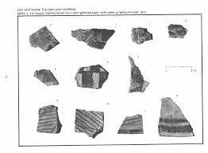

Taos Black on White
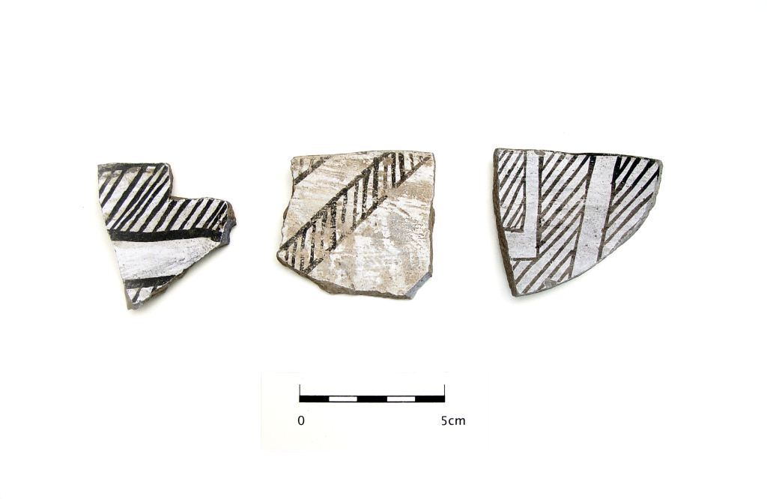
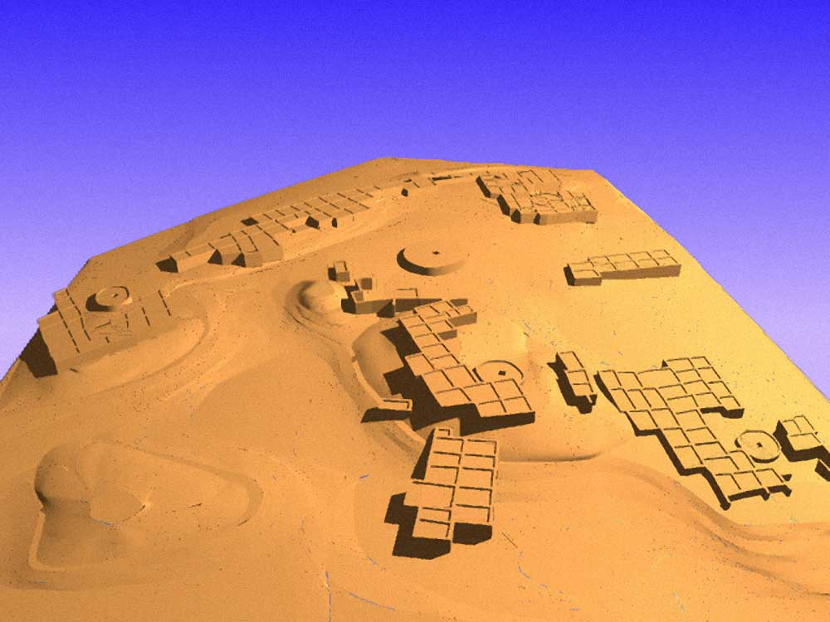

Pot Creek Pueblo 1320 AD

Slate of TAS Officer Elected for 2023-2024
February 1, 2023 until January 31, 2024

Phil Alldritt President
Cassandra Keyes Vice President
Debbie Espie Secretary
Chris Ellis Treasurer

Webmaster (Non Officer position)
Phil Alldritt

The Current Committee Chairs Are as follows:

Education Committee Anita Briscoe/Phil Alldritt

Fieldwork Committee Gary Grief

Scholarship Subcommittee Cassandra Keyes

Picuris Ceramic Analysis Committee Mark Henderson

Blumenshein Ceramic Analysis Committee For Charter Development
Kurt Weidler/ Jeff Boyer/Becky Quintana/Paul McGuff

Program Committee Cassandra Keyes, Debbie Dean, Phil Alldritt

Trip Committee Paul Reed , Phil Alldritt

Lifetime memberships are possible anytime for TAS. For $500.00 you will receive Lifetime membership plus 1. This can be a spouse or partner. Contact tasorg@hotmail.com if interested. Thank you!
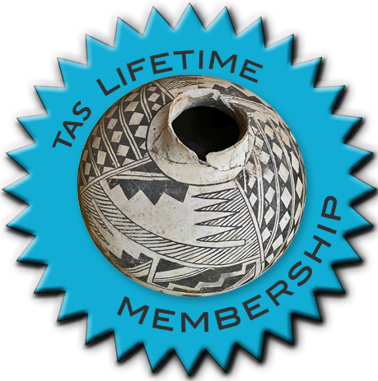

TAKING RESERVATIONS FOR
SPRING 2023!!!!!
The Taos Archaeological Society is Funding trips for students to The Mesa Prieta Petroglyph Project!! Trips coming up in Spring 2023!!!
Contact Phil Alldritt at taoscuba@hotmail.com

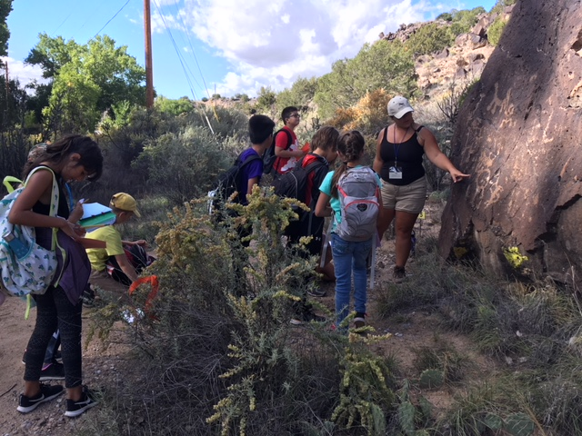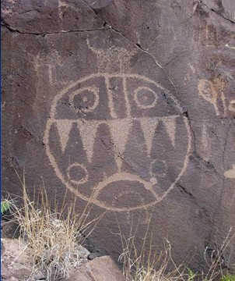

TAS is looking for Members to form an Education Committee who will promote and facilitate communication with teachers and schools to advance our bus trip programs!! To participate in this very successful effort contact Phil Alldritt at taoscuba@hotmail.com
Thank you!!!

Upcoming Trips
Trip reservations are first come first serve all trips have limited space. No reservation is confirmed until deposits have been made or Membership confirmed. Watch for future trips on the website!!!
Thank you!
PLANNED TRIPS FOR 2023
May 2023 Chaco Canyon Trip (Dates TBD)
June 2-3, 2023 Folsom Site Space Available (6)
October 2023 Bears Ears (Dates TBD)

All TAS trips may be sign up for by TAS Members who are Active Members in TAS. Persons wanting to participate should become Members by mailing 30.00 to
TAS
PO Box 143
Taos, NM 87571 Thank you

Next Speaker
April 3
Dr. Chip Wells
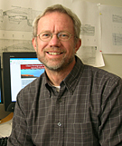

Chip Wells is an archaeologist and his research concerns the emergence of new socioeconomic
organization in the past, especially with respect to agriculture and food production. Sincecoming to the University of New Mexico, his field work has been in the American Southwest,
primarily in New Mexico. This field research has been fundamental to my work in four major
problem areas; 1) the introduction of agriculture during the Late Archaic period (ca. 4000 to
3000 B.C.), 2) the emergence of village communities during the Early Ceramic period (ca. A.D.
200 to 500), 3) the development of hierarchically complex corporate groups after A.D. 1000 in
the Colorado Plateau, and 4) the formation of Hispanic irrigation communities during the 18th
century in the northern Rio Grande Valley. Although these research problems represent widely
different time periods, his approach to each has been based on a common theoretical perspective
in which broad patterns of economic change are explained as the product of interaction among
relatively small social groups. His early research involving the transition from foraging to food
production focused heavily on the application of models derived from behavioral ecology, but as
his interests have grown to include more complicated social formations, he has been drawn
increasingly into areas involving historical economic theory. His work has been supported by
the National Science Foundation, the National Geographic Society, the Wenner-Gren
Foundation, the Smithsonian Institution, Sandia National Laboratories, the Western National
Parks Association and the American Philosophical Society.

TOPIC

The presentation will review archaeological research by the University of New Mexico at Chaco Culture National Historical Park over the past 18 years. Highlights include the documentation of multiple canals at Pueblo Bonito, the discovery of cacao in cylinder jars, excavations at the Wetherill Trading Post and the development of agricultural suitability models for the Chaco Basin. This research program continues the legacy of UNM and National Park Service partnerships at Chaco that began in 1929.

Exciting speakers coming all this year in 2023!!!! Watch for the bulletins beginning each month online at taosarch.org for announcements!!!!

.

.

