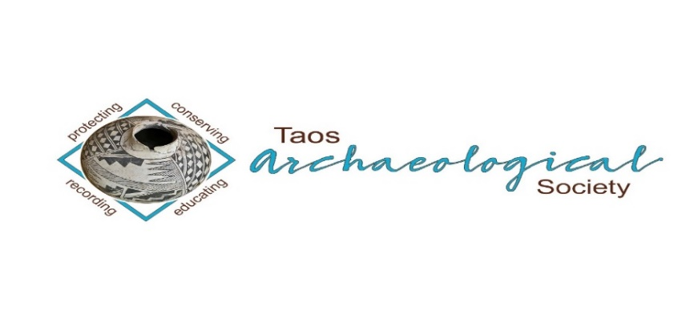
The Taos Archaeological Society

BULLETIN January 2023
HAPPY NEW YEAR!!!

THANK YOU EVERYONE WHO RENEWED THEIR MEMBERSHIP FOR 2023!!!!!

Next Speaker
January 9 MONDAY
ZOOM ONLY
ZOOM ID TO JOIN 545 842 9500
THIS WILL BE RECORDED

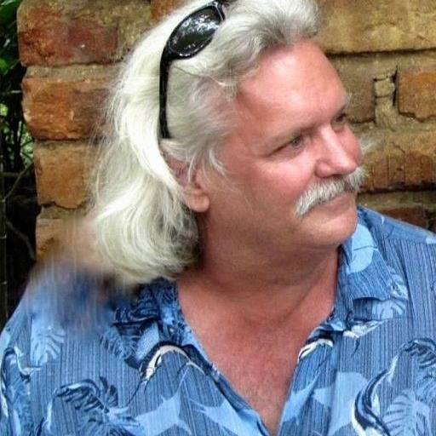

Phil Alldritt is an Instructor of Anthropology, Archaeology, History, and Political Science at the University of New Mexico -Taos since 2000. He is the Coordinator for the UNM-Taos Study Abroad Office.

His field school began in Belize in 1987 at Cuello Belize. He worked at the Maya site of Nohmul in Belize in 1989. In 1993, he worked on the Petexbatun Project at Quim chi Hilan an outlier from Aguateca in Guatemala. He has been a tour guide in Central America since 1984.

He has a BA in Political Science from Colorado State University and Master's Degree in Latin American Studies from the University of Arizona.
TOPIC
YAXCHILAN: Rulers of the Usumacinta River

During the height of the Classic Period of the Maya the rulers of Yaxchilan controlled the trade and territory near the confluence of the Pasion River. The art created at this site rivals Tikal and Copan for its beauty. We know so much from the narrative art and glyphs here that tell us about Maya ritual and their world view. New information has come to light regarding the rituals and new glyph decipherments. This talk will go into details about the ballgame and Maya warfare.

WELCOME BACK TO IN PERSON LECTURES. WE MEET AT THE KIT CARSON ELECTRIC COOP ON CRUZ ALTA at 7pm.
PLEASE BE VACCINATED AND BOOSTED FOR THE HEALTH AND SAFETY OF THE GROUP. Feel free to wear a mask according to your comfort level. We recommend this to stay safe from all air born transmission.
The TAS Monthly Lectures are recorded (unless the speaker requests we not record it) and will be available on You Tube three days after the live meeting.
Please watch your emails as we may move meetings to ZOOM only as Health protocols change or weather becomes an issue. Thank you.

ELECTION OF NEW OFFICERS FOR 2023-2024
Nominations for new officers will begin November 1, 2022. We will take nominations for 60 days until January 1, 2023. Then, a thirty-day electronic vote will be held until January 31, 2023. The new officers will be confirmed February 1, 2023. You can nominate an officer at taoscuba@hotmail.com. Thank you.
We are looking for 3 persons with fresh ideas and lots of energy to take over lead positions including President and Treasurer. Treasurer nominee should be familiar with Quik Books. Potential nominees can contact us at (taoscuba@hotmail.com) for more information concerning the duties of officers for TAS. The current officers are available to help with the transition next year.
TAS has completed 35 years of volunteer service in the Taos community. It has been an honor to represent the membership during the last 7 years. Thank you.

Message for the Members of TAS:

Hope you had a great summer and are all getting vaccinations and boosters so we can begin to have face to face meetings as soon as possible. We begin September 5, 2022 MONDAY to have in person lectures at the Kit Carson Electric Coop Board Room. 7pm -830pm as usual.
Please go to You Tube and Enter Taos Archaeological Society for recorded Lectures you may have missed.

The lectures from ASNM this Spring 2022 are recorded on You Tube.
Search: Archaeological Society of New Mexico Annual Meeting 2022 DAY One, DAY TWO, or DAY THREE.

Until then, stay healthy and safe,

Thank you and we will see you all soon.

The TAS Officers

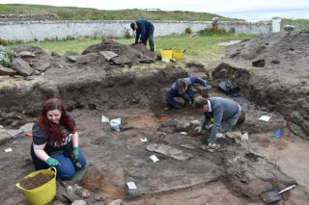

An effort is currently underway to build a historical timeline of events in the history of the Taos Archaeological Society. We need your help if you have records that date in the period September 1999 through February 2014. These dates range between the last completed history for the society and the earliest records archived on our web site.

The Taos Archaeological Society has operated for 34 years. At present documents we have accessible cover under 60 percent of that time. Old bulletins, meeting minutes, financial statements, member lists and other communications of the society will assist in this effort. Please do help if you can. You can send records directly to Paul McGuff (pmcguff@aol.com).

TAS, SMU-Taos and the Picuris Pueblo in Partnership!!!

A New Ceramic Analysis Committee Has been formed!!

Ceramic Sorting and Analysis is getting organized for a pilot project to have analysis conducted on a private take home individual basis to observe Covid-19.

Picuris Analysis Ceramic Sorting is still requesting volunteers to participate in processing out their Prehistoric collections. Contact Mark Henderson for more information. markscotthenderson@gmail.com

Sherder’s ZOOM MEETINGS temporarily suspended.

Zoom Id Number Meeting ID: 878 3989 2686

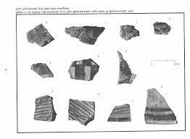

Taos Black on White
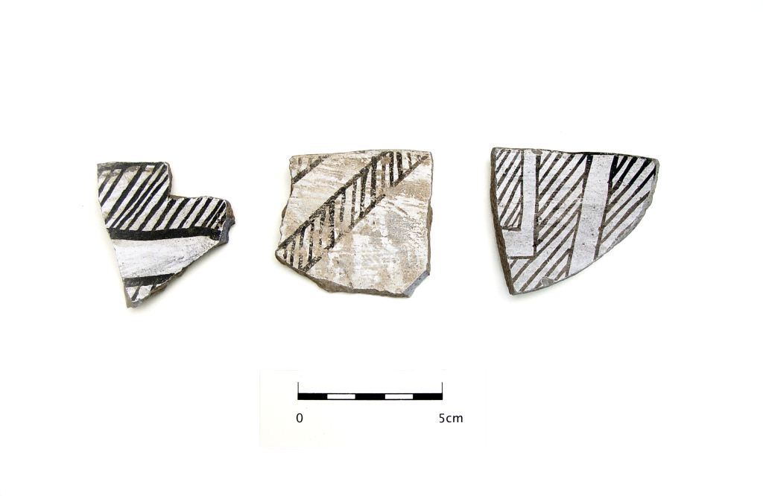
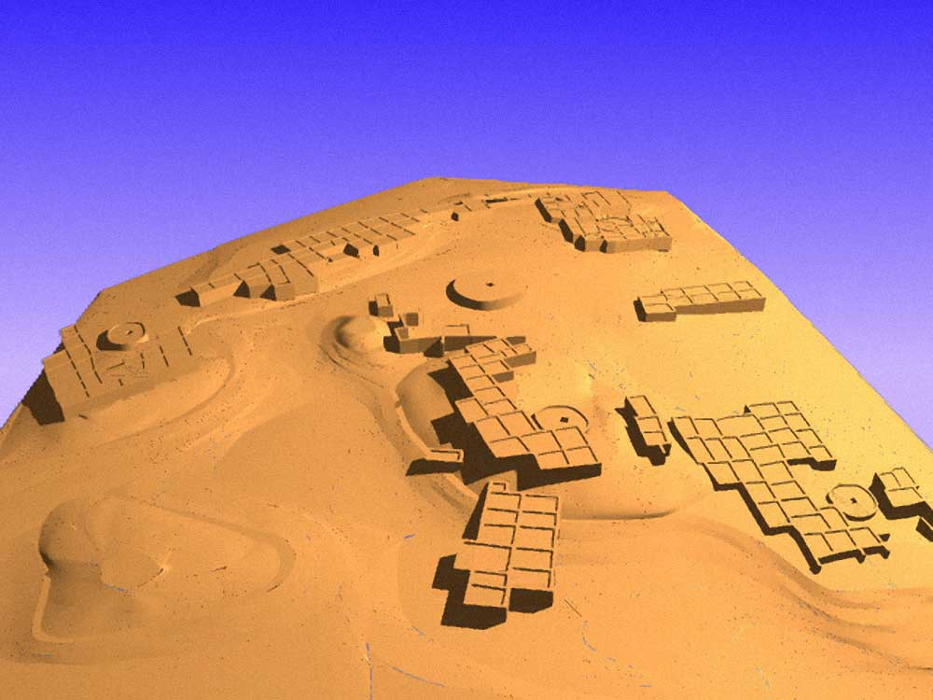

Pot Creek Pueblo 1320 AD

Slate of TAS Officer Elected for 2022-2023
February 1, 2022 until January 31, 2023

Phil Alldritt President
Cassandra Keyes Vice President
Debbie Espie Secretary
Chris Ellis Treasurer

Webmaster (Non Officer position)
Phil Alldritt

The Current Committee Chairs Are as follows:

Education Committee Anita Briscoe

Fieldwork Committee Gary Grief

Newman Dome Subcommittee Cassandra Keyes

Picuris Ceramic Analysis Committee Mark Henderson

Blumenshein Ceramic Analysis Committee For Charter Development
Kurt Weidler/ Jeff Boyer/Becky Quintana/Paul McGuff

Program Committee Cassandra Keyes, Debbie Dean, Phil Alldritt

Trip Committee Paul Reed , Phil Alldritt

Lifetime memberships are possible anytime for TAS. For $500.00 you will receive Lifetime membership plus 1. This can be a spouse or partner. Contact tasorg@hotmail.com if interested. Thank you!
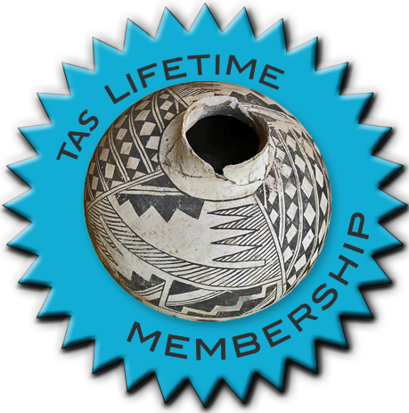

TAKING RESERVATIONS FOR
SPRING 2023!!!!!
The Taos Archaeological Society is Funding trips for students to The Mesa Prieta Petroglyph Project!! Trips coming up in Spring 2023!!!
Contact Phil Alldritt at taoscuba@hotmail.com

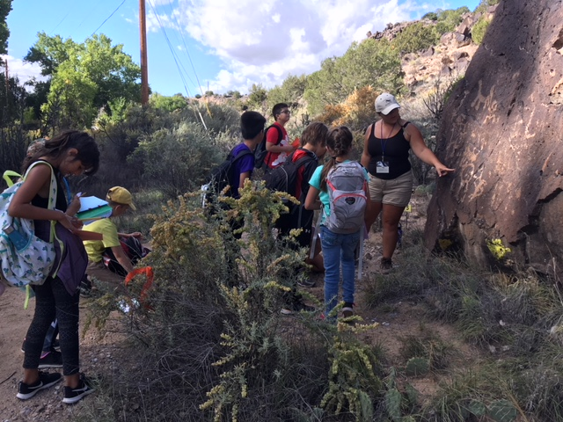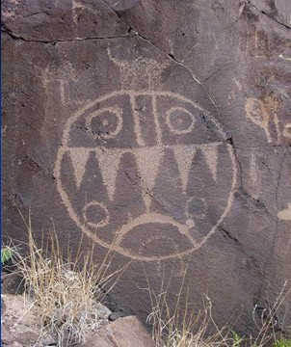

TAS is looking for Members to form an Education Committee who will promote and facilitate communication with teachers and schools to advance our bus trip programs!! To participate in this very successful effort contact Phil Alldritt at taoscuba@hotmail.com
Thank you!!!

Upcoming Trips
Trip reservations are first come first serve all trips have limited space. No reservation is confirmed until deposits have been made. Watch for future trips on the website!!!
Thank you!
All TAS trips may be sign up for by TAS Members who are Active Members in Good Standing. Persons wanting to participate should become Members by mailing 30.00 to
TAS PO Box 143 Taos, NM 87571 Thank you
NEXT SPEAKER
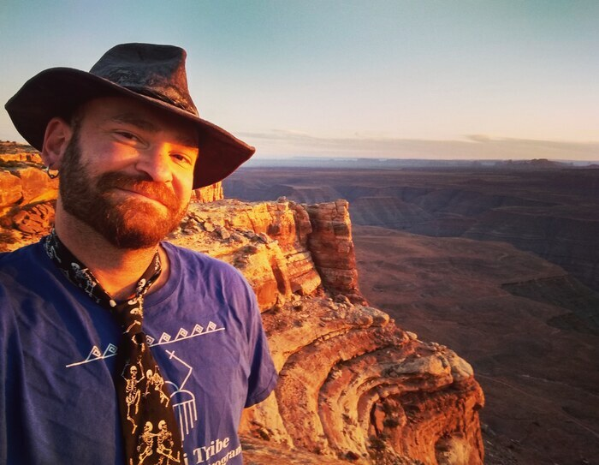
February 6, 2023
Ralph Burrillo
Bears Ears
7pm Mountain

Ralph "R.E." Burrillo is an archaeologist, author, and conservation advocate with degrees from Northern Arizona University and the University of Utah. His writing has appeared in Archaeology Southwest, Colorado Plateau Advocate, The Salt Lake Tribune, Blue Mountain Shadows, The Moab Times, The Navajo-Hopi Observer, Kiva, The Gulch, The Dust, The Archaeological Record, Flag Live, The San Juan Record, and Southwestern Lore. He is also the author of Behind the Bears Ears: Exploring the Cultural and Natural Histories of a Sacred Landscape, which was chosen by ForeWord Book Reviews as their critic's choice in nonfiction for the year 2020; and the more recent The Backwoods of Everywhere: Words from a Wandering Local. He currently splits his time between Scottsdale and Flagstaff, AZ.

TOPIC
About the talk: "The Battle for Bears Ears: 120 Years of Conservation History." Southeastern Utah has one of richest and most diverse sagas of human history, dating back at least 12,000 years. Since its popularization starting in the 1870s, the rich material heritage of the place has faced steady threats from development, grazing, looting, and - increasingly - recreational visitation. Efforts to implement legislative protection have existed for almost as long, but have always lagged far behind the pace of the impacts they are meant to curtail. Now they are on a collision course whose fate is yet to be determined.

Exciting speakers coming all next year in 2023!!!! Watch for the bulletins beginning each month online at taosarch.org for announcements!!!!

.

.

