The Taos Archaeological Society
August 10, 2021
5:30pm (Sign in by 5:25pm) Zoom ID 545 842 9500

Speaker August 10, 2021
Karen Clary
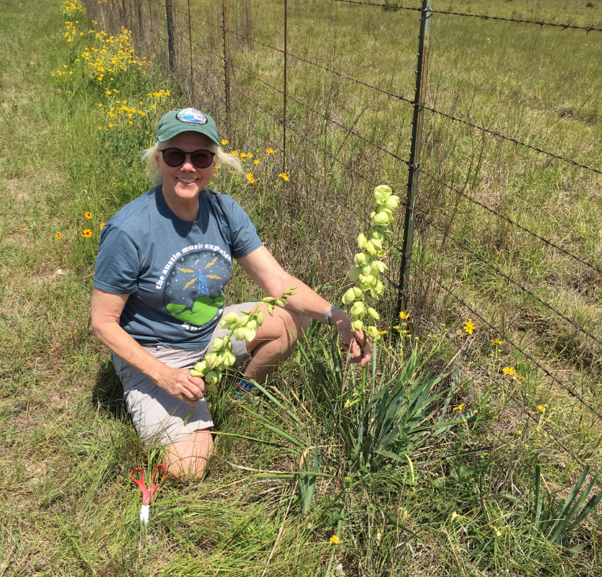
Back in 1978, Karen co-founded the Castetter Laboratory for Ethnobotanical Studies at UNM with Mollie Struever Toll and Anne Calvert Cully. The lab undertook ethnobotanical analyses of plant remains from archeological sites all over New Mexico, mostly for the OCA at UNM and the Lab of Anthroplogy in Santa Fe. In 1988, Karen moved to Texas and got a Ph.D. in Botany from the University of Texas where she studied taxonomy and biogeography of the Yucca species, which, by the way, are only native to the new world. She spent the rest of her career working on plant and natural resource conservation and retired in 2017 from the Lady Bird Johnson Wildflower Center, Austin, as Director of the Plant Conservation Program. She now volunteers as a lecturer for a variety of plant classes at the Wildflower Center, including general taxonomy, ethnobotany and economic botany. This year she also joined the IUCN species Red List Team to assess extinction threats for Yucca species.

Topic
The title of my talk is "The food the Ancient Chaco People ate - what the archeological record does and does not tell us," I will talk about how archeobotanists get plant remains from dirt at archeological sites and the ethnobotanical record we mine to connect plant remains found in sites to ancient lifeways, among other things, with a focus on the San Juan Basin.

Message for the Members of TAS:

Hope you are having a great summer and all getting vaccinations so we can begin to have face to face meetings as soon as possible. As of now, we will continue to have Zoom lectures until January 2022.

We are mostly restricted as the Kit Carson is not allowing any groups to meet in person yet. We will keep you updated when that changes. This, of course, is their decision.

Please go to You Tube and Enter Taos Archaeological Society for recorded Lectures you may have missed.

Until then, stay healthy and safe,

Thank you and we will see you all soon.

The TAS Officers

In Memoriam

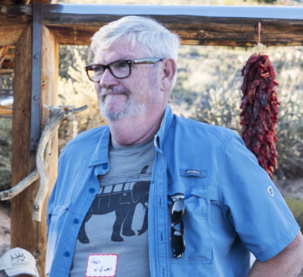

Paul “Pablo” Williams was born and raised in CO, went to the University of the South in Sewaunee, TN and the University of CO to study anthropology and work at Mesa Verde National Park. In 1985 he received an MS in anthropology from Northern Arizona University. Then he worked everywhere - Colorado, Arizona, Utah, Montana - in museums, National Forests and colleges.
In 1984 he came to Taos as the first archaeologist in the BLM office. In addition to his job, he became involved with local archaeological projects such as the Taos Archaeological Society and MPPP.
Important efforts in his career include management of archaeological sites in the Ojo Caliente area and work to get the Galisteo Basin Archaeological Sites Protection Act passed by Congress.
Pablo, as he is affectionately known by his friends and colleagues, is a great hero to the MPPP for his 10 years of partnership with our Summer Youth Intern Program (SYIP). Without his leadership and 10 days of working in the field with teenagers in the SYIP program every year, the BLM Suburban he brings to help haul kids around the mesa, and the funding help he procures from the BLM to support the program, it would never have succeeded the way it has.
With Paul’s help we’ve managed to have a SYIP program every summer for 10 years. Again, thanks to Paul, in 2011 the MPPP in partnership with the BLM won a national Take Pride in America® Award. And again, thanks to Paul and the BLM we were able to take five youngsters from the program to Washington DC to receive the award. “Pablo the Bear” is the biggest and one of the very most important allies the MPPP has ever had. We thank him for all that he has done for us.
Que descansando en Paz Pablo. You will be greatly missed by all who ever met you.
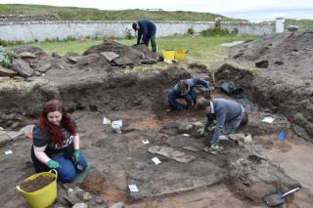

An effort is currently underway to build a historical timeline of events in the history of the Taos Archaeological Society. We need your help if you have records that date in the period September 1999 through February 2014. These dates range between the last completed history for the society and the earliest records archived on our web site.

The Taos Archaeological Society has operated for 34 years. At present documents we have accessible cover under 60 percent of that time. Old bulletins, meeting minutes, financial statements, member lists and other communications of the society will assist in this effort. Please do help if you can. You can send records directly to Paul McGuff (pmcguff@aol.com).

TAS, SMU-Taos and the Picuris Pueblo in Partnership!!!

A New Ceramic Analysis Committee Has been formed!!

Ceramic Sorting and Analysis is getting organized for a pilot project to have analysis conducted on a private take home individual basis to observe Covid-19.

Picuris Analysis Ceramic Sorting is still requesting volunteers to participate in processing out their Prehistoric collections. Contact Mark Henderson for more information. markscotthenderson@gmail.com

Join the Sherders Zoom meetings each Wednesday at 9am to get updated on the activities going forward.

Zoom Id Number Meeting ID: 878 3989 2686

Taos Black on White
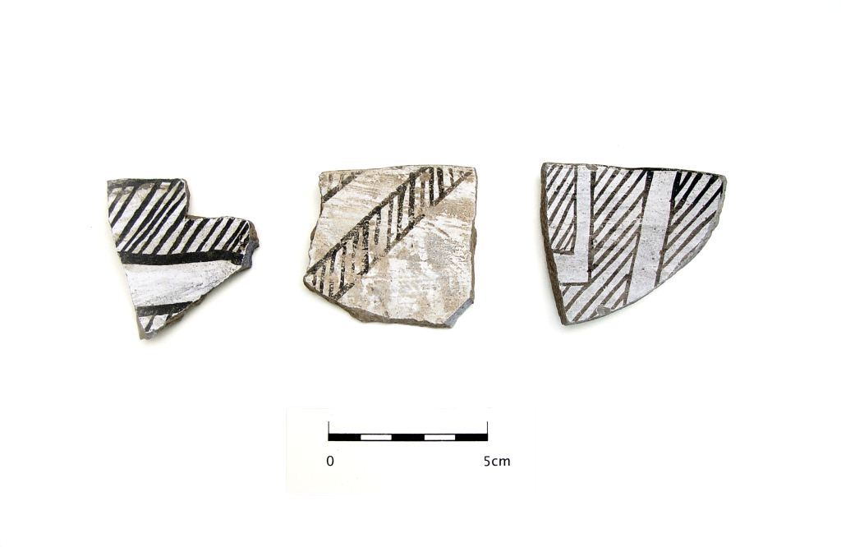
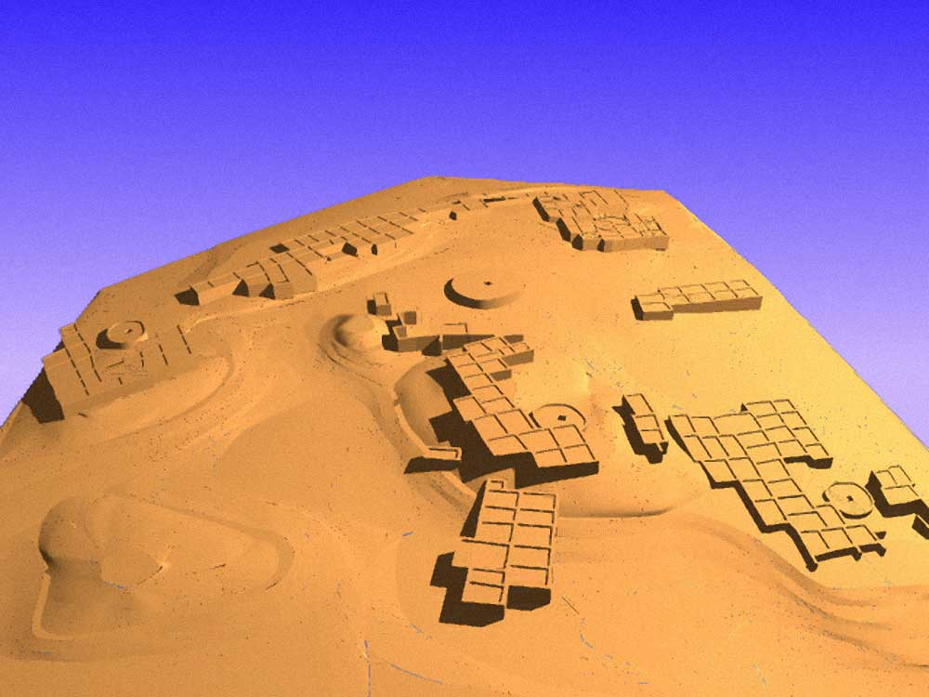

Pot Creek Pueblo 1320 AD

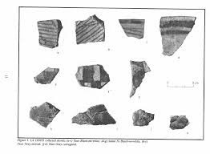
Slate of TAS Officer Elected for 2021-2022
February 1, 2021 until January 31, 2022

Phil Alldritt President
Nancy Colvert Vice President
Debbie Espie Secretary
Chris Ellis Treasurer
Anita Briscoe At Large
Cassandra Keyes At Large

Webmaster (Non Officer position)
Phil Alldritt

The Current Committee Chairs Are as follows:

Education Committee Anita Briscoe

Fieldwork Committee Gary Grief

Newman Dome Subcommittee Cassandra Keyes

Picuris Ceramic Analysis Committee Mark Henderson

Blumenshein Ceramic Analysis Committee For Charter Development
Kurt Weidler/ Jeff Boyer/Becky Quintana

Program Committee Cassandra Keyes, Debbie Dean, Phil Alldritt

Trip Committee Paul Reed , Phil Alldritt

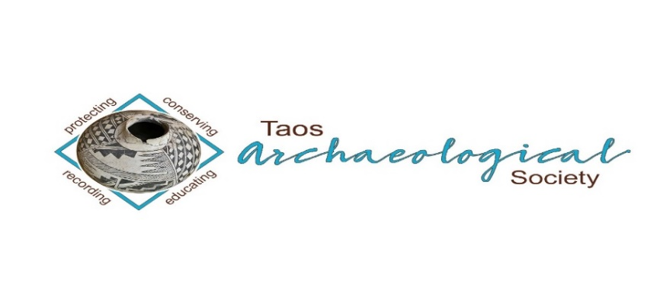
The Taos Archaeological Society is pleased to announce we are hosting the Annual Meeting of ASNM. The Conference will take place May 6-8, 2022 next Spring. TAS is looking for volunteers to participate in helping Saturday May 7. The Meeting theme will be “Taos at the Crossroads of Trade”.

Register on the TAS website coming soon at taosarch.org

Interesting lectures, Field Trips, Steve Lekson keynote speaker and Banquet Dinner. Burro loading demonstration,
Silent Auction.

Contact Phil Alldritt at taoscuba@hotmail.com to participate as a volunteer.
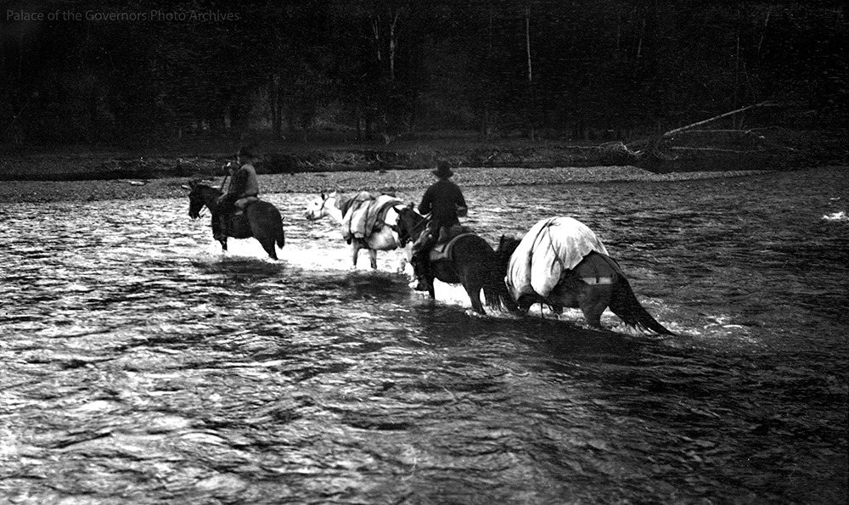

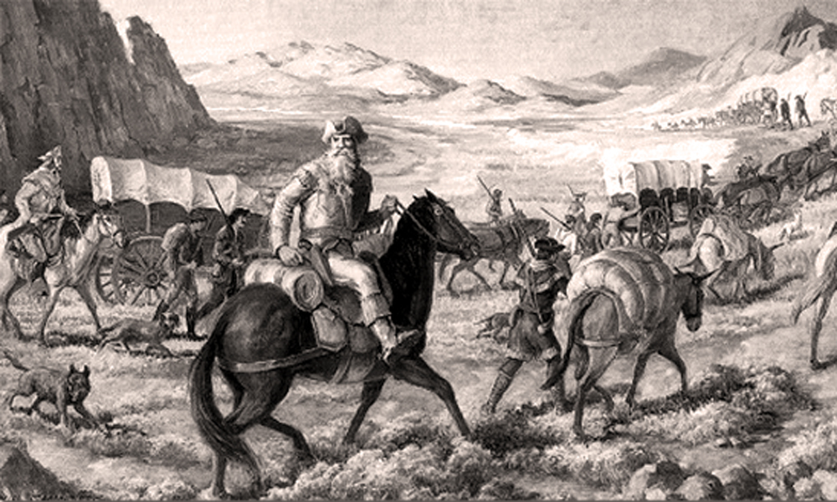

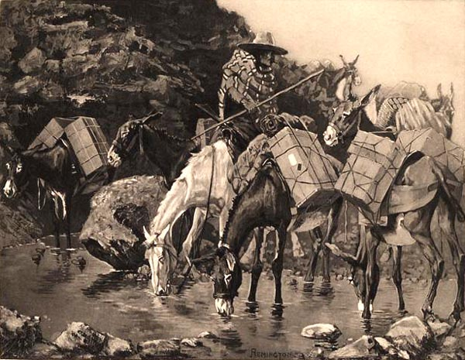

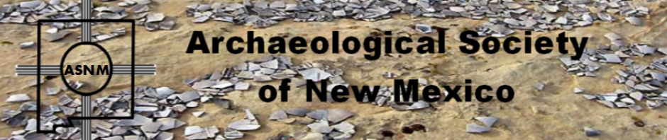

Budget information for 2020 for the Taos Archaeological Society is now posted on the website.

2021 Membership Dues can be paid now!!!!

The Taos Archaeological Society is offering Lifetime Membership with the contribution of $500.00 per individual anytime up until December 31, 2021. Take advantage of this Tax Deductible opportunity and help TAS fund our mission!! The Lifetime Membership will include the Member plus 1 additional family member.
TAS
PO Box 143
Taos, NM 87571

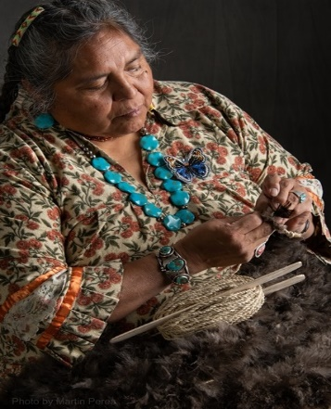
THIS ACTIVITY Has Been Rescheduled for Saturday JUNE 11, 2022
Members already paid are signed up!!!

To the Membership of the Taos Archaeological Society,

On Saturday, June 11 ,2022, Mary Motah will conduct a basket and sandal weaving demonstration and hands on workshop for TAS members. The workshop will take place at the Kit Carson Board Room on Cruz Alta Road from 10am-4pm.

The participation is limited to 15 persons. This will fill quickly. Registration based on first 15 payments received. Please include your email to receive a confirmation.

If you miss out we will do this in an ongoing basis. The second 15 payments received will be confirmed to participate in the June 2023 workshop.

The participation fee is $15.00 check or money order made out to Mary Motah. It should be mailed to

Phil Alldritt
PO Box 659
Arroyo Hondo, NM 87513

First 15 deposits received are confirmed. No one is confirmed until payment is received.

Participants should bring a small pocket knife, wear shorts, bring brownbag lunch and drink.

In case of cancellation and you request a refund contact me here.

Thank you for your support and participation in the TAS activities!!

STAND BY FOR UPDATES FOR
WINTER POT LUCK

TAKING RESERVATIONS FOR SPRING 2022!!!!!
The Taos Archaeological Society is Funding trips for students to The Mesa Prieta Petroglyph Project!! Trips coming up in Spring 2022!!! COVID PERMITTING!!!
Contact Phil Alldritt at taoscuba@hotmail.com

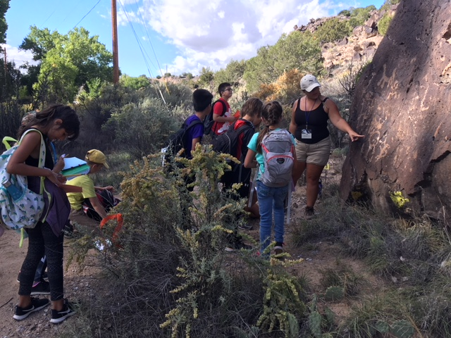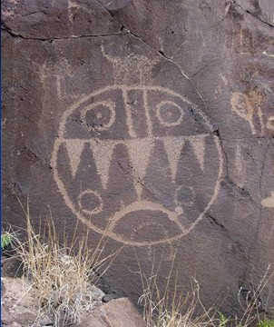

TAS is looking for Members to form an Education Committee who will promote and facilitate communication with teachers and schools to advance our bus trip programs!! To participate in this very successful effort contact Phil Alldritt at taoscuba@hotmail.com
Thank you!!!

Upcoming Trips
Trip reservations are first come first serve all trips have limited space. No reservation is confirmed until deposits have been made. Watch for future trips on the website!!!
Thank you! COVID PERMITTING!!!
All TAS trips may be sign up for by TAS Members who are Active Members in Good Standing. Persons wanting to participate should become Members by mailing 30.00 to
TAS PO Box 143 Taos, NM 87571 Thank you!!!

Next Speaker
September 14, 2021

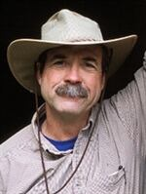
Tradition, and Sheepscapes
By Andrew Gulliford
February 2021
From his book The Woolly West: Colorado’s Hidden History of Sheepscapes, Dr. Andrew Gulliford will speak about poor Hispanic sheepherders pastores, and wealthy Hispanic sheep owning families or ricos who transformed the West by the grazing of thousands of sheep across New Mexico and Colorado. He will discuss the history of sheep grazing as well as describe a powerful love story between Aldo Leopold and Estella Luna Otero Bergere. Gulliford will discuss the brutal sheep and cattle wars and explain historical archaeology and the wide variety of sites related to sheep movements, sheep camps, cairns, aspen tree carvings, and lonely sheepherder lifeways in Colorado’s high country for summer grazing. He will show photographs, and discuss cultural traditions and stories of Hispano herders who have grazed and still graze U.S. National Forest and BLM lands. Questions and stories from the audience will be welcomed.
Gulliford received the National Individual Volunteer Award from the U.S. Forest Service. The Woolly West won the Colorado Book Award for History and the Wrangler Western Heritage Award for Outstanding Non-Fiction from the National Cowboy Museum & Heritage Center. Dr. Gulliford is a professor of history at Fort Lewis College in Durango.
Andrew Gulliford is a professor of history and Environmental Studies at Fort Lewis College in Durango, Colorado. He teaches popular courses on wilderness, national parks, Western history, and environmental history. He is the author of America’s Country Schools, Sacred Objects and Sacred Places: Preserving Tribal Traditions, and Boomtown Blues: Colorado Oil Shale, which won the Colorado Book Award. He edited Preserving Western History, which was voted one of the best books on the Southwest by the Tucson-Pima County Library. His book Outdoors in the Southwest: An Adventure Anthology won the Arizona/New Mexico Book Award in the category of nature/environment and Best Book on Arizona. Outdoors in the Southwest also won the Colorado Book Award for best anthology.
Gulliford has had led tours across the West by canoe, raft, horseback, van, cruise ship, private train, and private jet for the Smithsonian Institution, National Geographic Society, the National Trust for Historic Preservation, Rocky Mountain Public Broadcasting Service (PBS), Great Old Broads for Wilderness, History Colorado, Canyon Country Discovery Center, and the San Juan Mountains Association.
Dr. Gulliford has received the National Individual Volunteer Award from the U.S. Forest Service for wilderness education, and a certificate of recognition from the Secretary of Agriculture for “outstanding contributions to America’s natural and cultural resources.” For a decade he held a federal appointment to the Southwest Colorado Resources Advisory Council of the Bureau of Land Management. He also served on Colorado’s State Review Board for the state and historical registers of historic places. In 2016 he was one of two senior fellows awarded the Aldo and Estella Leopold Residency at Tres Piedras, New Mexico to research and write in the bungalow Aldo built for his wife in 1912 on the Carson National Forest.
Gulliford edited The Last Stand of the Pack: A Critical Edition, published by the University Press of Colorado. He writes columns about the Southwest for the Durango Herald, the Cortez Journal, and the San Juan Record (Monticello, Utah) and he appears in history programs for “The Colorado Experience” television series produced by Rocky Mountain PBS. He has appeared in films about The Cattle and Sheep Wars; The Press of the West; Senator Ben Nighthorse Campbell; and The Strater Hotel.
His book The Woolly West: Colorado’s Hidden History of Sheepscapes (Texas A&M University Press, 2018) was chosen the Outstanding Nonfiction winner for the 2019 Western Heritage Awards sponsored by the National Cowboy & Western Heritage Museum in Oklahoma City. The Woolly West also won the Colorado Book Award in 2019.

Exciting speakers coming all next year 2021and 2022!!!! Watch for the bulletins beginning again in September online at taosarch.org for announcements!!!!

.

.

