The Taos Archaeological Society
Thursday May 5, 2022
12:00pm (Sign in by 11:50am) Zoom ID 545 842 9500

The Archaeological Society of New Mexico and the Taos Archaeological Society present

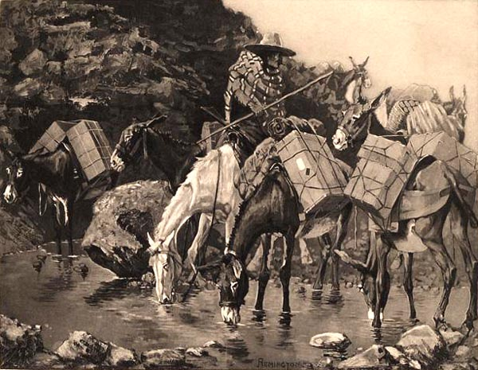

Taos at the Crossroads of Trade

ASNM Virtual Meetings for 2022 May 5-7, 2022
Thursday May 5, 2022 12:00pm-2:30pm MST
Friday May 6, 2022 12:00noon-4:30pm MST
Saturday May 7, 2022 12:00 noon-4:30pm MST

ONLINE Auction April 7 (12 noon) – May 7 (12 noon)

Panelists: Phil Alldritt, Jeff Boyer, Cassandra Keyes

Thursday May 5
Opening Introductions 12: Noon-12:30pm
Land Acknowledgement Indigenous Blessing
Speaker #1 Michael Mathiowetz PhD.
12:30pm-1:30pm
Speaker #2 Susan Boyle PhD.
1:30pm-2:30pm
Closing Remarks

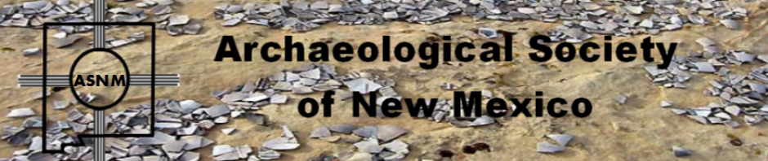

Friday May 6
Opening Remarks and Comments 12:00noon to 12:10pm
Speaker #1
12:10pm-1:10pm Price Heiner
Speaker #2
1:10pm-2:10pm Dianne Archuleta
Speaker #3
2:30pm-3:30pm Dean Wilson

Speaker #4
3:30pm-4:30pm Patricia Crown Phd.
Closing Remarks

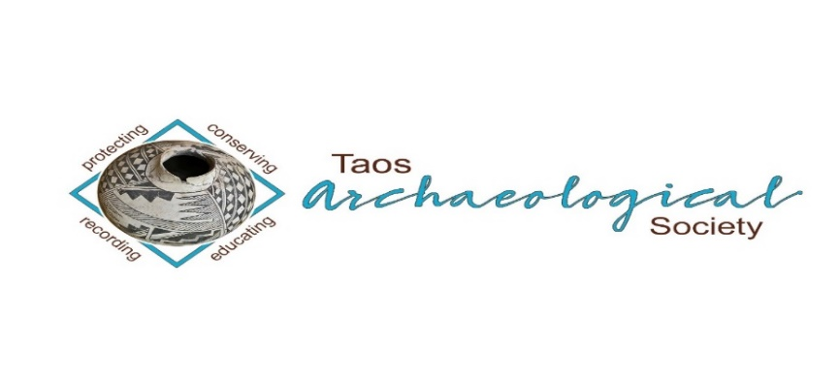

Saturday MAY 7
Opening Remarks and Comments
12:00noon=12:10pm
Speaker #1
12:10pm-1:10pm Severin Fowles Phd.
Speaker #2 Catrina Whitley Phd.
1:10pm-2:10pm
Speaker #3 Stephen Lekson Phd.
2:30pm-3:30pm
END OF LECTURES
3:30pm-4:30pm
ANNOUNCEMENT OF AUCTION WINNERS
AWARDS CEREMONY BICE AWARDS AND SCHOLARSHIPS
CLOSING REMARKS AND VIDEO
FREE REGISTRATION T0 PARTICIPANTS
REGISTRATION $0.00
CONTRIBUTOR $15.00 (Access to recordings)
PATRON $30.00 (Access to recordings)
DONATOR $ 50.00 or more
(Access to recordings and free t-shirt)

Travis Kern
TAS Scholarship Awardee Congratulations!!!
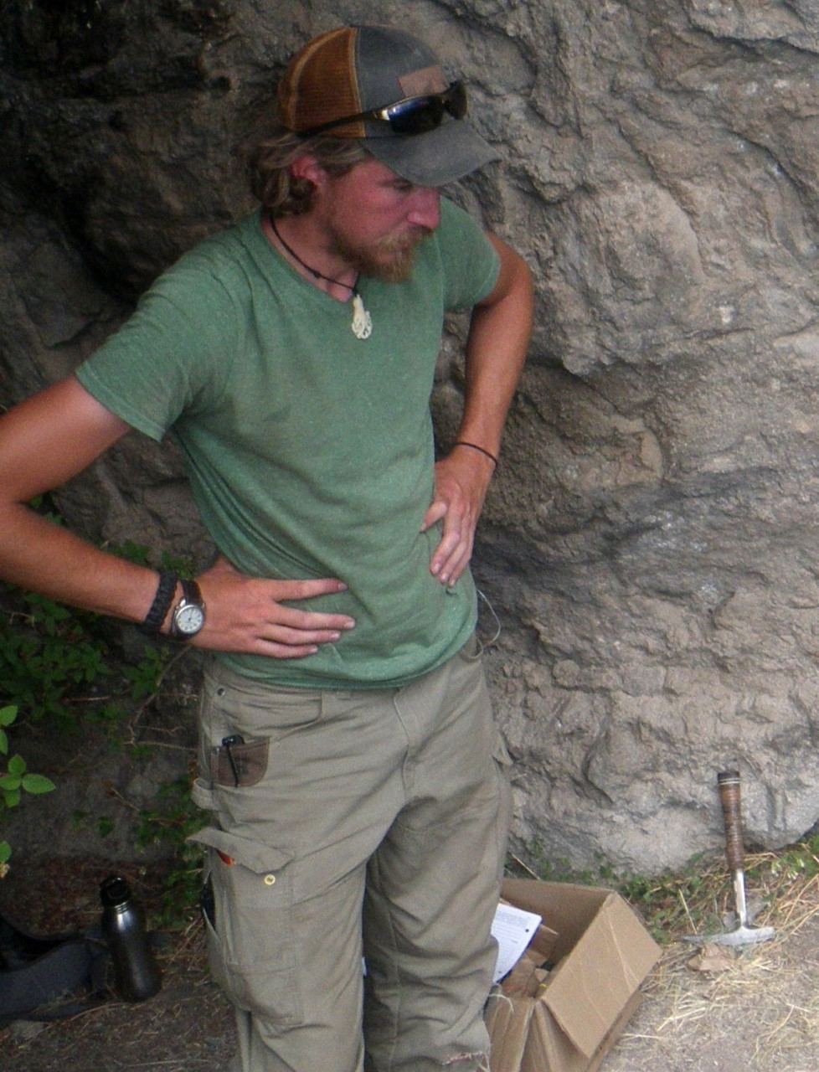
The purpose of this application is to demonstrate a little about where I have been, where I am now, and where I plan on going in respect to archaeology. My career with archaeology began when in field school working in the Valles Caldera Summer of 2016. I was working on my bachelor’s degree in history at Missouri State University and it was required that I needed to have a minor. I took an introductory class with Dr. Frederick Scott Worman under whom I learned a vast amount of the job requirements.
My first archaeology gig was working at the Bessey Ranger District in the Nebraska National Forest, where I spent the summer working before completing a Graduate Certificate in Cultural Resource Management. The summer after completing the graduate certificate I was an emergency hire for the Carson National Forest, a place that I would work during the next three summers, learning the rich history of the land, not only culturally, but ecologically and geographically as well. I spent most winters working for various archaeology firms working in Missouri, Arkansas, Texas, New Mexico, and West Virginia. However, my heart has always been drawn to the Rocky Mountains and working with lithic technologies.
Winter of 2021, I was accepted to University of Montana where I am working on my Masters. I am studying a Late Paleoindian Site located in Yellowstone National Park, hoping to help prove the Foothill-Mountain culture complex. The Foothill-Mountain culture was believed by George Frison to be an adapted culture to year-round life in the more alpine regions of the Rocky Mountains versus the Plains Cody Culture. The Foothill-Mountain culture has varied
degrees and no set styles of lithic technology causing many variants to be named aftedegrees and no set styles of lithic technology causing many variants to be named after local place names.
By analyzing the projectile point located within Yellowstone and I hope by comparing them to other projectile points that date to similar time periods with similar ecological tendencies we can establish that Frison’s adapted culture did in fact survive year-round in the more high-altitudes, and hopefully can understand how by analyzing these similar sites. Admittedly this will be challenging without blood residue analysis as well as any faunal remains that can or have been found.
My goal is to finish school and I believe I will continue to work for the Forest Service, working my way up the ladder. New Mexico has a special place in my heart and I hope someday to make my way back to work in New Mexico, though in the meantime I intend to work throughout the Rocky Mountains. I hope this will also provide the opportunity to work on Late Paleoindian sites as well.
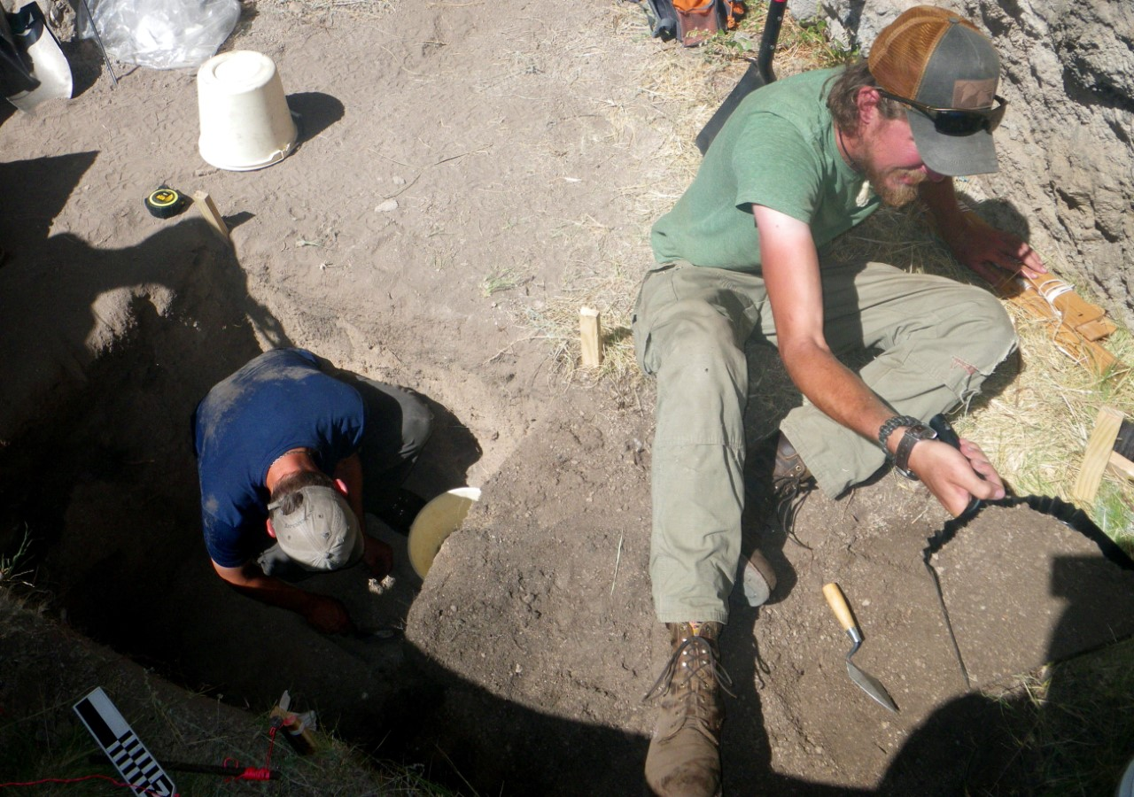

Bears Ears Trip Opportunity June 2-5, 2022

2022 Taos Archaeological Society Bears Ears Trip
Andrew Gulliford, trip leader
June 2-5, 2022 Itinerary Subject to Change based on weather.
Mandatory VACCINATION, BOOSTER and MASKS REQUIRED FOR INDOOR ACTIVITIES.

Canyon Country Discovery Center.

Date/Time Place_________________

Thursday June 2 5 p.m. Meet in Monticello, Utah at the Canyon Country
Discovery Center
6 p.m. Group dinner out.

Friday June 3 9 a.m. Daily Briefing Safety and Ethics
Edge of the Cedars State Park &
Museum for tour and museum visit. Have a full
tank of gas.

11:00 Leave for Comb Wash Camp Site.
Set up camp. Have lunch.

1 p.m. Carpool to Mule Canyon Roadside Site along HWY 95.

1:45 p.m. Visit Canyon Towers Site on state land.

4 p.m. Visit Salvation Knoll and learn Bluff and
Mormon history.

5:00 Return to camp. Happy hour.

6:00 Dinner at camp.

Saturday June 4 ^{8 a.m.} Breakfast and see Comb Wash Great House Kivas.
Daily Briefing Safety and Ethics
Carpool to upper Butler Wash. Hike into Ballroom Cave Ruin and Inscription House.

Noon Back to camp for lunch.

1 p.m. Carpool to Cottonwood Wash Great House.

2 p.m. Hike into Two-Story House.

4 p.m. Hike to petroglyph panel at the end of Comb Ridge at the old highway 95 cut.

5:00 Return to camp and Happy Hour.

6:00 Dinner.

Sunday June 5 9 a.m. Breakfast and break camp. Pack your lunch.

Daily Briefing Safety and Ethics
Carpool to Arch Canyon and take rim hike out to look at ruins in Arch Canyon.
Walk to the edge of the Moqui Dugway and hear a story about it and what’s below in Valley of the Gods. Return to Bluff via Moqui Dugway.
See rock art at Upper Sand Island Campground.

Sunday 5:00 Wine, beer, and cheese reception at Andy’s house in
Bluff for folks staying the night in Bluff.

This trip is considered to be MODERATE HIKING

Trip cost $480.00 per person (10 person MAXIMUM)

Trip cost includes one night hotel (double), 8 meals, camp cook, guiding and entrance fees, permits, reserved camping areas, and extra water.

NOT INCLUDED
Transportation to Utah, camping gear, backpack, water bottles, sunglasses, sunscreen, rain gear, good hiking boots, personal first aid, extra food and snacks, last night hotel in Bluff.

You MUST be an active current Member of the Taos Archaeological Society to participate.
Trip waivers will be signed for the Outfitters and the
Taos Archaeological Society.
Contact taoscuba@hotmail.com for questions
Trip confirmation based on first come first served receipt of 200.00 per person deposits and Proof of Vaccinations and Boosters (taoscuba@hotmail.com)
TAS PO Box 659 Arroyo Hondo, NM 87513

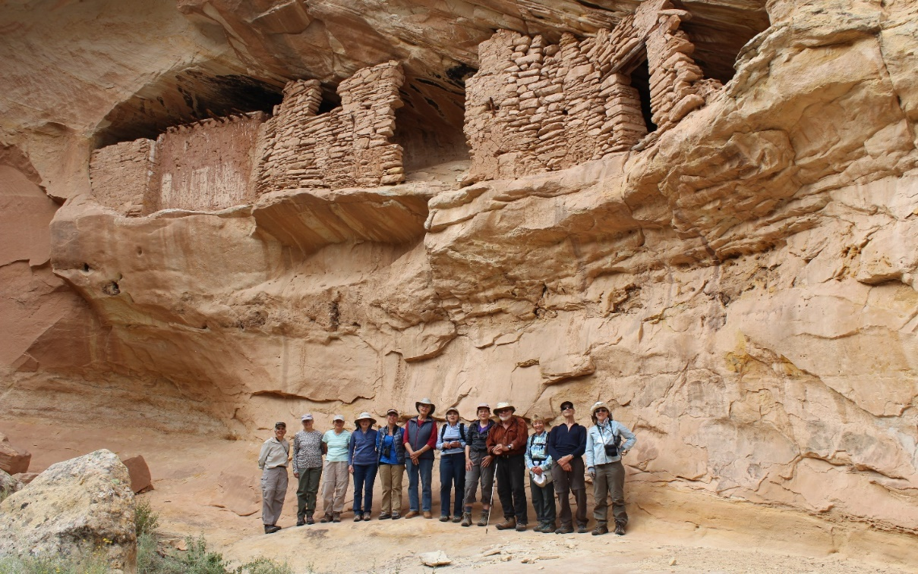

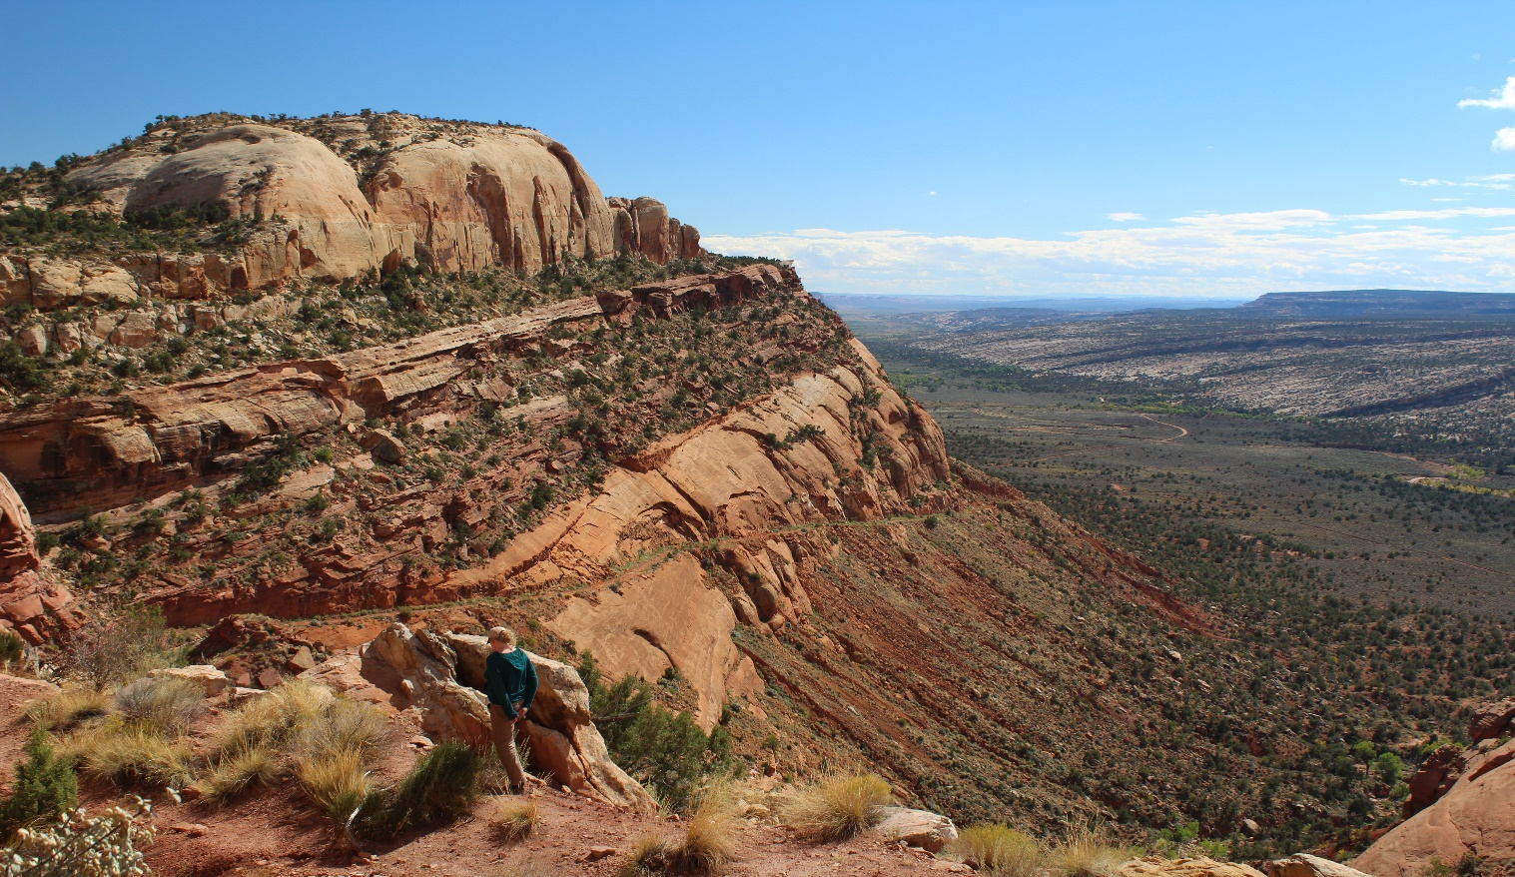
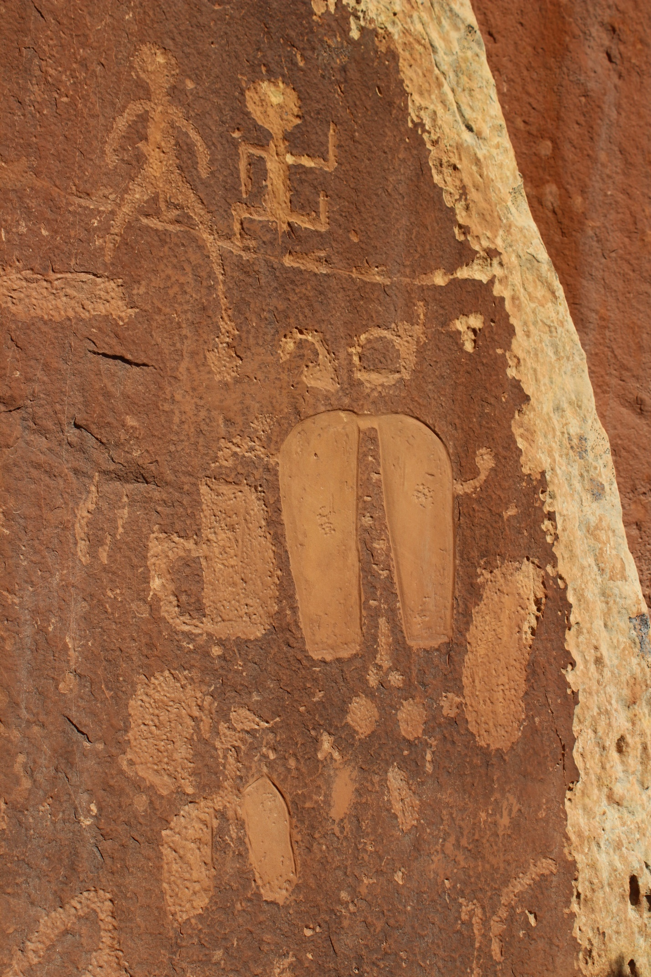
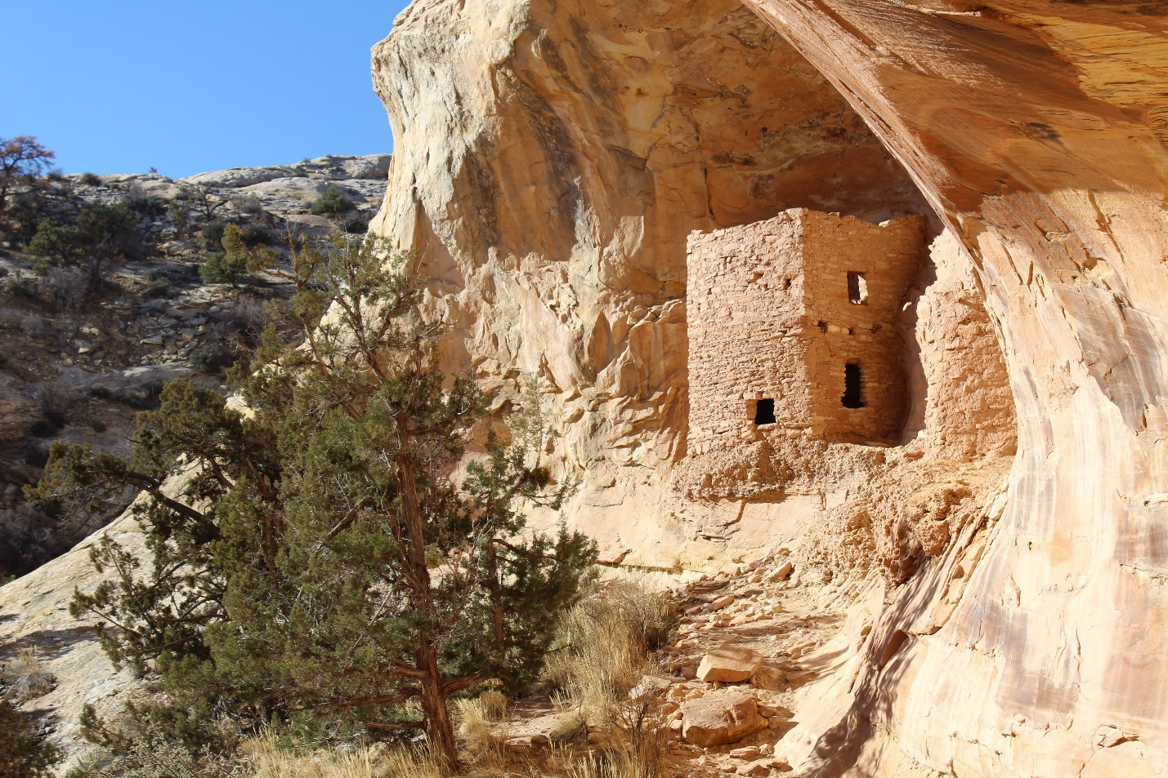
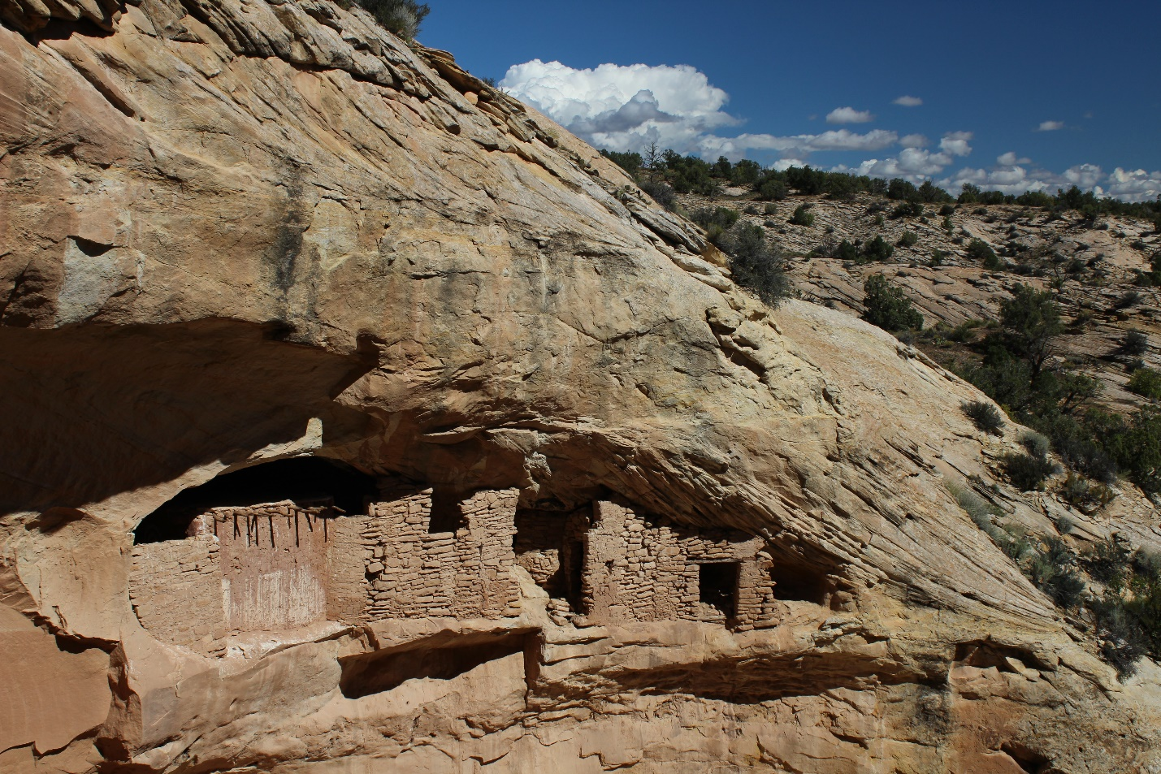

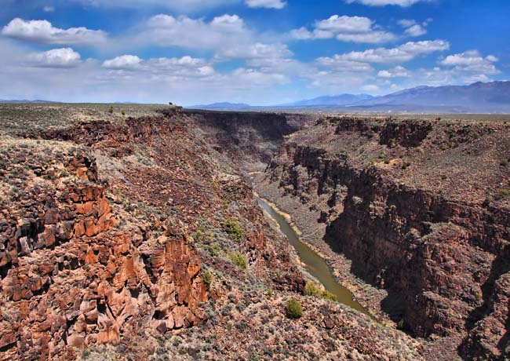
On September 25 and 26 TAS volunteers, in partnership with Natalie Sanford from the Bureau of Land Management Taos Field Office, began preliminary survey and artifact documentation of the Newman Dome archaeological site. This is planned as a collaborative multi-year project between TAS and the BLM and is expected to continue next September. The TAS volunteers included Cassandra Keyes (Newman Dome Subcommittee Chairperson), Tim Viereck, Joel Clark, and Bob and Sara Blair. Natalie Sanford was Field Supervisor.
Newman Dome was used by indigenous groups for thousands of years as a lithic procurement site. The material that these folks were collecting is known as dacite- a black volcanic rock that is similar to basalt- which they used for making projectile points and other tools.
The first day of fieldwork was dedicated to pedestrian survey, artifact identification, and flagging of tools. Over 50 tools were identified and flagged and were recorded on the second day. Over the course of the weekend, volunteers not only learned how to identify bifacially worked artifacts, various projectile point types, and ground stone artifacts, but also learned how to measure, describe, and photograph artifacts according to scientific standards!
Dr. Steve Shackley, professor emeritus of UC-Berkley, joined the group on Sunday to provide an overview of the geologic history of the Taos Plateau and the formation of Newman’s Dome with an emphasis on why this particular feature was targeted for tool stone.
The BLM will begin working on an initial report during the winter.
Very many thanks to Bob and Sara Blair for providing food for the crew and for organizing first aid and logistical support and to Mark Henderson for providing equipment.

Message for the Members of TAS:

Hope you are having a great spring and all getting vaccinations and boosters so we can begin to have face to face meetings in September 2022. As of now, we will continue to have Zoom lectures until May 2022.

Please go to You Tube and Enter Taos Archaeological Society for recorded Lectures you may have missed.

Until then, stay healthy and safe,

Thank you and we will see you all soon.

The TAS Officers

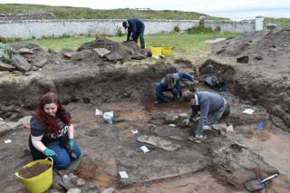

An effort is currently underway to build a historical timeline of events in the history of the Taos Archaeological Society. We need your help if you have records that date in the period September 1999 through February 2014. These dates range between the last completed history for the society and the earliest records archived on our web site.

The Taos Archaeological Society has operated for 34 years. At present documents we have accessible cover under 60 percent of that time. Old bulletins, meeting minutes, financial statements, member lists and other communications of the society will assist in this effort. Please do help if you can. You can send records directly to Paul McGuff (pmcguff@aol.com).

TAS, SMU-Taos and the Picuris Pueblo in Partnership!!!

A New Ceramic Analysis Committee Has been formed!!

Ceramic Sorting and Analysis is getting organized for a pilot project to have analysis conducted on a private take home individual basis to observe Covid-19.

Picuris Analysis Ceramic Sorting is still requesting volunteers to participate in processing out their Prehistoric collections. Contact Mark Henderson for more information. markscotthenderson@gmail.com

Sherder’s ZOOM MEETINGS 10:00am Wednesdays

Join the Sherders Zoom meetings each Wednesday at 9am to get updated on the activities going forward.

Zoom Id Number Meeting ID: 878 3989 2686

Taos Black on White
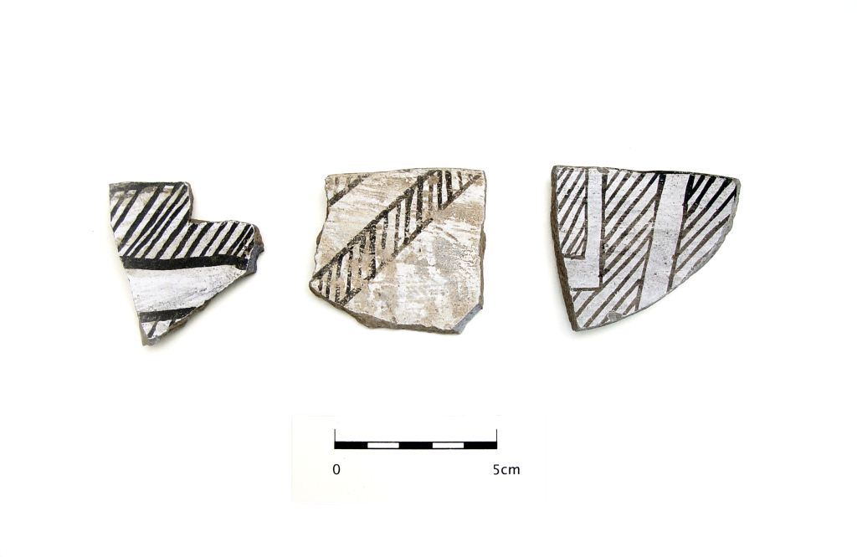
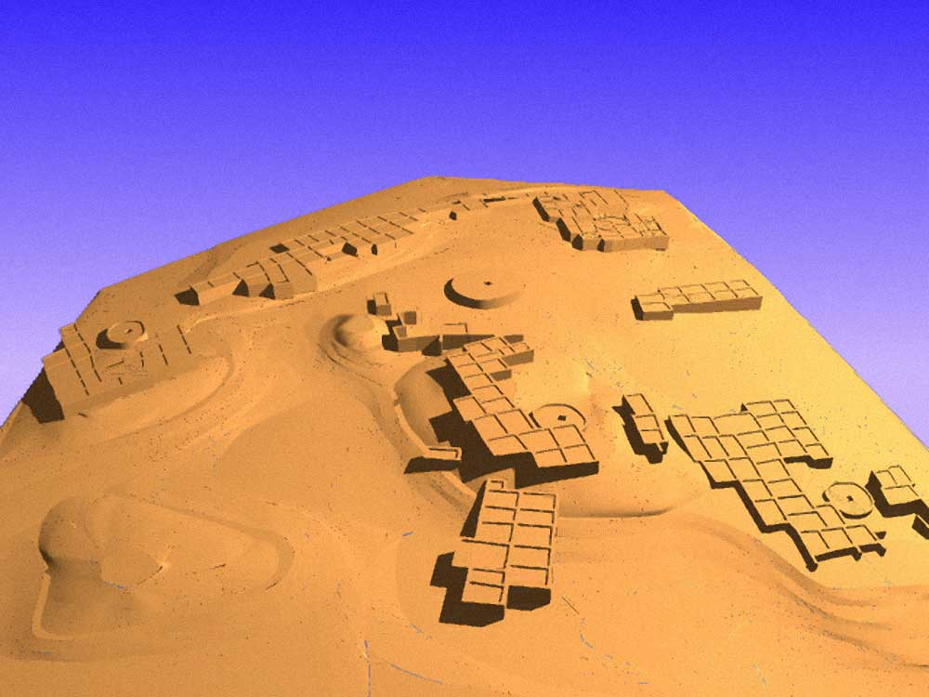

Pot Creek Pueblo 1320 AD

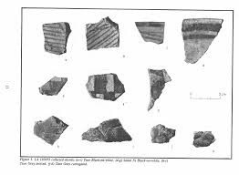
Slate of TAS Officer Elected for 2021-2022
February 1, 2021 until January 31, 2022

Phil Alldritt President
Cassandra Keyes Vice President
Debbie Espie Secretary
Chris Ellis Treasurer

Webmaster (Non Officer position)
Phil Alldritt

The Current Committee Chairs Are as follows:

Education Committee Phil Alldritt

Fieldwork Committee Gary Grief

Newman Dome Subcommittee Cassandra Keyes

Picuris Ceramic Analysis Committee Mark Henderson

Blumenshein Ceramic Analysis Committee For Charter Development
Kurt Weidler/ Jeff Boyer/Becky Quintana/Paul McGuff

Program Committee Cassandra Keyes, Debbie Dean, Phil Alldritt

Trip Committee Paul Reed , Phil Alldritt

The Taos Archaeological Society is pleased to announce we are hosting the ONLINE VIRTUAL Annual Meeting of ASNM. The Conference will take place May 5-7, 2022. The Meeting theme will be “Taos at the Crossroads of Trade”.

Register on the TAS website coming soon at taosarch.org

Interesting lectures, and Silent Auction. Sapawe field trip.

Contact Phil Alldritt at taoscuba@hotmail.com to ask any questions
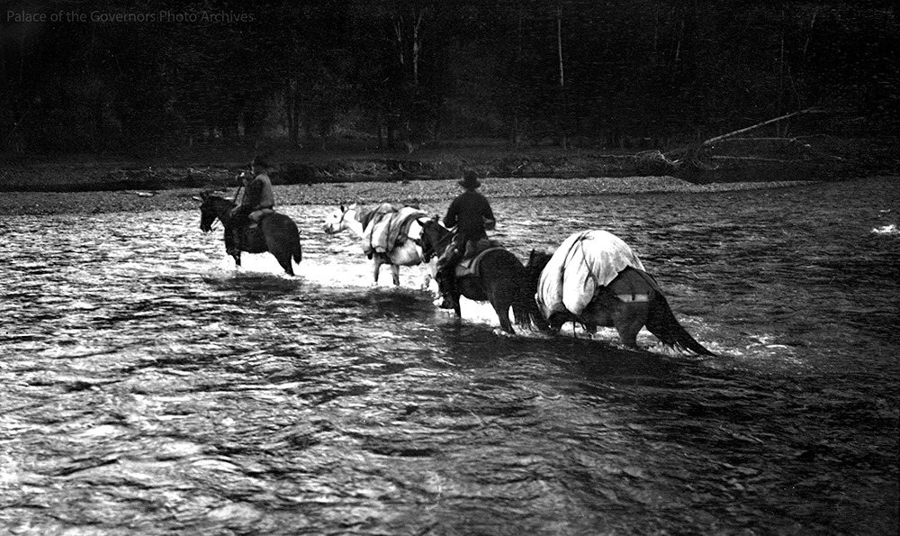

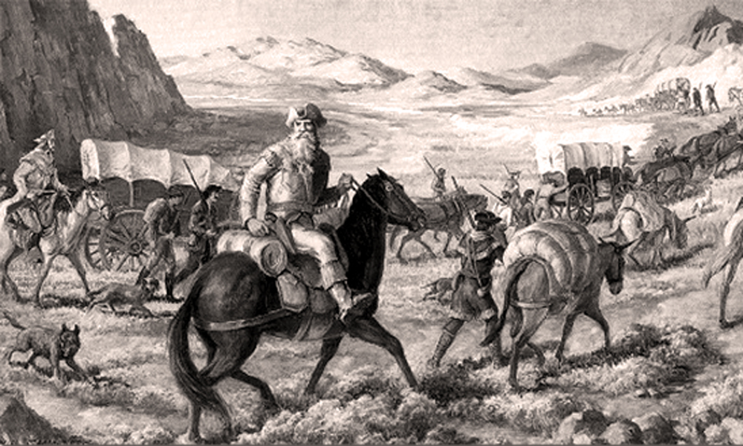

Budget information for December 2021 for the Taos Archaeological Society is now posted on the website.

2022 Membership Dues can be paid now!!!!

The Taos Archaeological Society is offering Lifetime Membership with the contribution of $500.00 per individual anytime. Take advantage of this Tax Deductible opportunity and help TAS fund our mission!! The Lifetime Membership will include the Member plus 1 additional family member.
TAS
PO Box 143
Taos, NM 87571

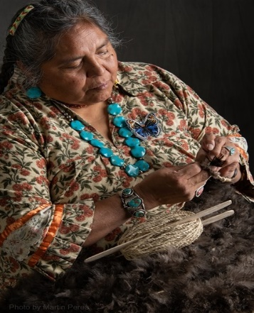
THIS ACTIVITY Has Been Rescheduled for Saturday JUNE 10, 2023
Members already paid are signed up!!!

To the Membership of the Taos Archaeological Society,

On Saturday, June 10, 2023, Mary Motah will conduct a basket and sandal weaving demonstration and hands on workshop for TAS members. The workshop will take place at the Kit Carson Board Room on Cruz Alta Road from 10am-4pm.

The participation is limited to 15 persons. This will fill quickly. Registration based on first 15 payments received. Please include your email to receive a confirmation.

If you miss out we will do this in an ongoing basis. The second 15 payments received will be confirmed to participate in the June 2023 workshop.

The participation fee is $15.00 check or money order made out to Mary Motah. It should be mailed to

Phil Alldritt
PO Box 659
Arroyo Hondo, NM 87513

First 15 deposits received are confirmed. No one is confirmed until payment is received.

Participants should bring a small pocket knife, wear shorts, bring brownbag lunch and drink.

In case of cancellation and you request a refund contact me here.

Thank you for your support and participation in the TAS activities!!

SUMMER 2022 SUMMER POT LUCK
July 31, 2022
5:00pm-7:00pm.
Bring your favorite summer dish and LAWN CHAIR!!
Location: 92 Buggy Road, Arroyo Seco 87514

TAKING RESERVATIONS FOR SPRING 2022!!!!!
The Taos Archaeological Society is Funding trips for students to The Mesa Prieta Petroglyph Project!! Trips coming up in Spring 2022!!! COVID PERMITTING!!!
Contact Phil Alldritt at taoscuba@hotmail.com

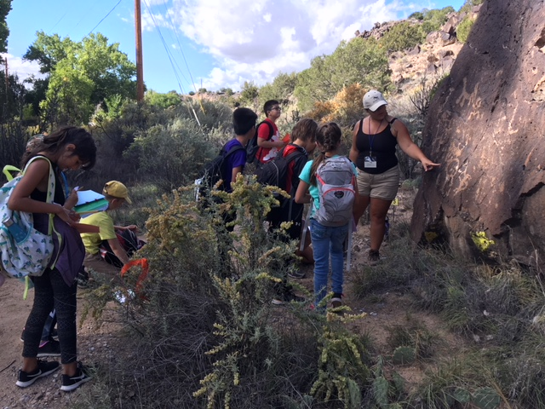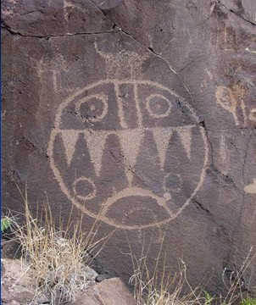

TAS is looking for Members to form an Education Committee who will promote and facilitate communication with teachers and schools to advance our bus trip programs!! To participate in this very successful effort contact Phil Alldritt at taoscuba@hotmail.com
Thank you!!!

Upcoming Trips
Trip reservations are first come first serve all trips have limited space. No reservation is confirmed until deposits have been made. Watch for future trips on the website!!!
Thank you! COVID PERMITTING!!!
All TAS trips may be sign up for by TAS Members who are Active Members in Good Standing. Persons wanting to participate should become Members by mailing 30.00 to
TAS PO Box 143 Taos, NM 87571 Thank

Next Speakers
MAY 5-7, 2022
Please join us for the ASNM Annual Meeting
Register at taosarch.org.
9 FANTASTIC Lectures over three days.

The Archaeological Society of New Mexico and the Taos Archaeological Society present

Taos at the Crossroads of Trade

ASNM Virtual Meetings for 2022 May 5-7, 2022
May 5, 2022 12:00pm-2:30pm MST
May 6-7, 2022 12:00noon-4:30pm MST
ONLINE Auction April 7 (12 noon) – May 7 (12 noon)

Panelists: Phil Alldritt, Jeff Boyer, Cassandra Keyes
May 5
Opening Introductions 12: Noon-12:30pm
Land Acknowledgement Indigenous Blessing
Speaker #1 Michael Mathiowetz PhD.
12:30pm-1:30pm
Speaker #2 Susan Boyle PhD.
1:30pm-2:30pm
Closing Remarks
May 6
Opening Remarks and Comments 12:00noon to 12:10pm
Speaker #1
12:10pm-1:10pm Price Heiner
Speaker #2
1:10pm-2:10pm Dianne Archuleta
Speaker #3
2:30pm-3:30pm Dean Wilson

Speaker #4
3:30pm-4:30pm Patricia Crown Phd.
Closing Remarks
MAY 7
Opening Remarks and Comments
12:00noon=12:10pm
Speaker #1
12:10pm-1:10pm Severin Fowles Phd.
Speaker #2 Catrina Whitley Phd.
1:10pm-2:10pm
Speaker #3 Stephen Lekson Phd.
2:30pm-3:30pm
END OF LECTURES
3:30pm-4:30pm
ANNOUNCEMENT OF AUCTION WINNERS
AWARDS CEREMONY BICE AWARDS AND SCHOLARSHIPS
CLOSING REMARKS AND VIDEO
FREE REGISTRATION T0 PARTICIPANTS
REGISTRATION $0.00
CONTRIBUTOR $15.00 (Access to recordings)
PATRON $30.00 (Access to recordings)
DONATOR $ 50.00 or more
(Access to recordings and free t-shirt)

Exciting speakers coming all next year in the Fall 2022 and 2023!!!! Watch for the bulletins beginning each month online at taosarch.org for announcements!!!!

.

.

