The Taos Archaeological Society
March 9, 2021

5:30pm (Sign in by 5:25pm) Zoom ID 545 842 9500

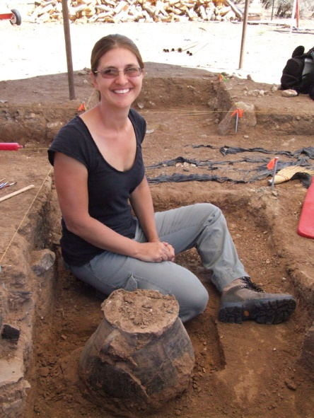

Catrina Banks Whitley, PhD,
Southern Methodist University,RPA Bioarchaeology Support
Research Associate, Office of Archaeological Studies,
Museum of New Mexico,Santa Fe

Ongoing investigations at the BaahKu Archaeological Site

Occupation of the Taos Valley was one of the latest areas inhabited by Ancestral Puebloans and is interpreted as a frontier area. Recent excavations at the BaahKu archaeological site provide an example of an architectural construction unique to the Taos Valley along with unusual abandonment processes. This research presents a comparison between two pithouses in close proximity to each other, to highlight the differences present in the Valley providing evidence for the frontier hypothesis. We will also present a greater geographic architectural analysis for the Taos Valley through tim
The Taos Archaeological Society is always looking for volunteers to participate in activities and volunteer as officers. Please contact taoscuba@hotmail.com to volunteer opportunities

Thank you for your continuing support of TAS.

A New Ceramic Analysis Committee Has been formed!!

Ceramic Sorting and Analysis is getting organized for a pilot project to have analysis conducted on a private take home individual basis to observe Covid-19.

Pot Creek Ceramic Sorting is still requesting volunteers to participate in processing out their Prehistoric collections. Contact Mark Henderson for more information. markscotthenderson@gmail.com

Join the Sherders Zoom meetings each Wednesday at 9am to get updated on the activities going forward.

Zoom Id Number Meeting ID: 878 3989 2686

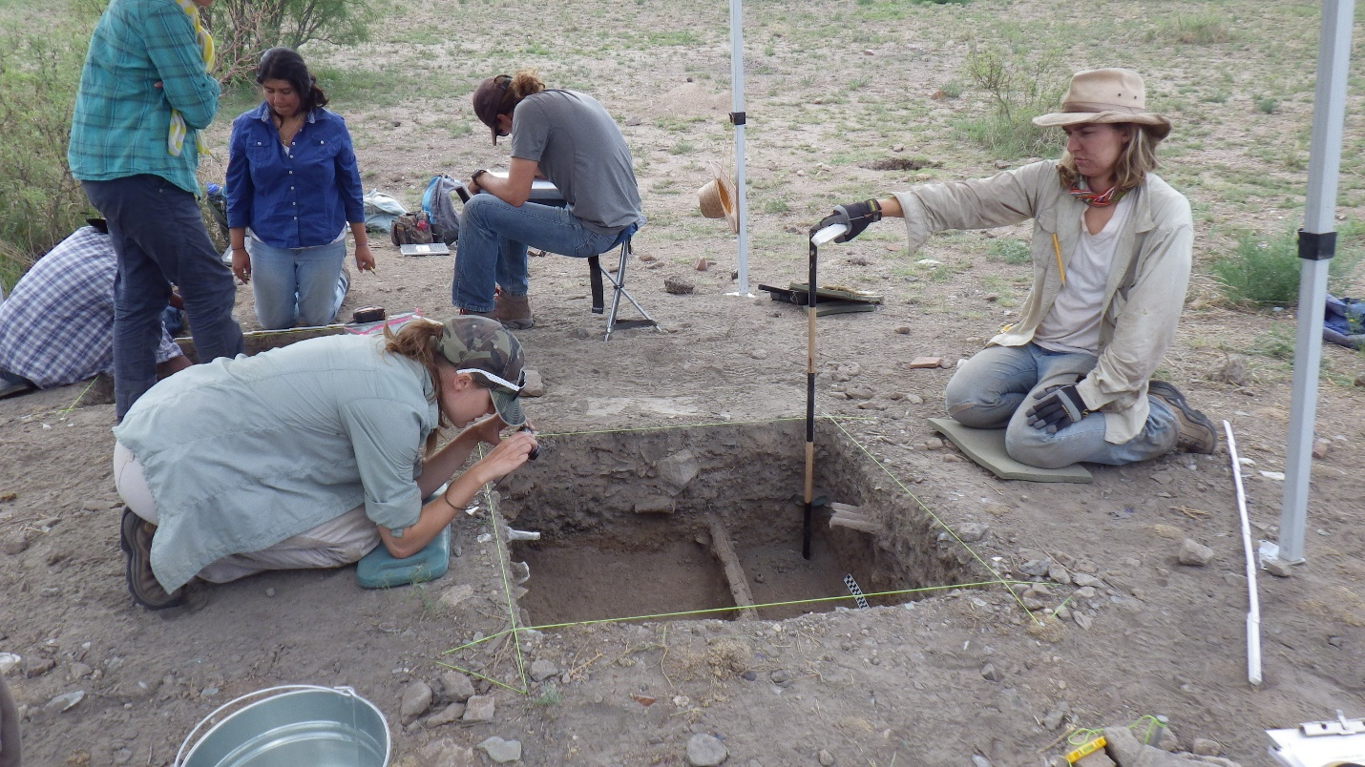

An effort is currently underway to build a historical timeline of events in the history of the Taos Archaeological Society. We need your help if you have records that date in the period September 1999 through February 2014. These dates range between the last completed history for the society and the earliest records archived on our web site.

The Taos Archaeological Society has operated for 34 years. At present documents we have accessible cover under 60 percent of that time. Old bulletins, meeting minutes, financial statements, member lists and other communications of the society will assist in this effort. Please do help if you can. You can send records directly to Paul Mcguff (pmcguff@aol.com).

Taos Black on White
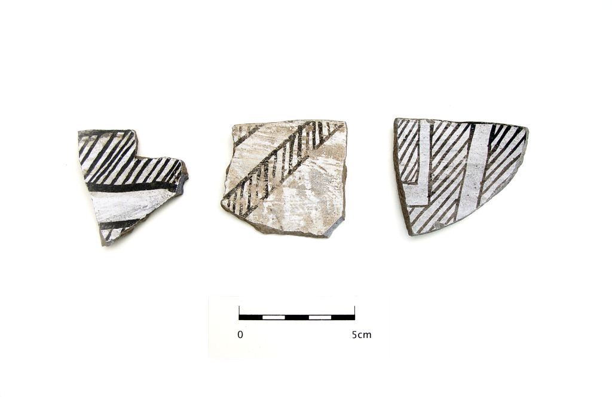
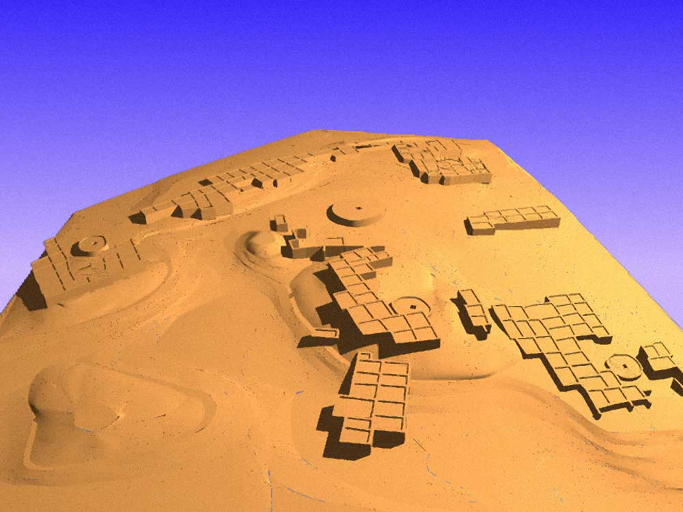

Pot Creek Pueblo 1320 AD

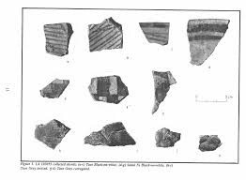

Slate of TAS Officer Elected for 2021-2022
February 1, 2021 until January 31, 2022

Nancy Colvert
Phil Alldritt
Anita Briscoe
Debbie Espie

TAS welcomes Katheryn Ritter as our new Webmaster and newest member!! We are excited to have her participating in our group!! Welcome!!

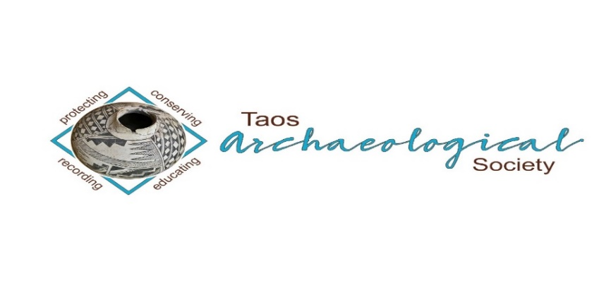
The Taos Archaeological Society is pleased to announce we are hosting the Annual Meeting of ASNM. The Conference will take place May 6-8, 2022 next Spring. TAS is looking for volunteers to participate in helping Saturday May 7. The Meeting theme will be “Taos at the Crossroads of Trade”.

Register on the TAS website coming soon at taosarch.org

Interesting lectures, Field Trips, Steve Lekson keynote speaker and Banquet Dinner. Burro loading demonstration,
Silent Auction.

Contact Phil Alldritt at taoscuba@hotmail.com to participate as a volunteer.
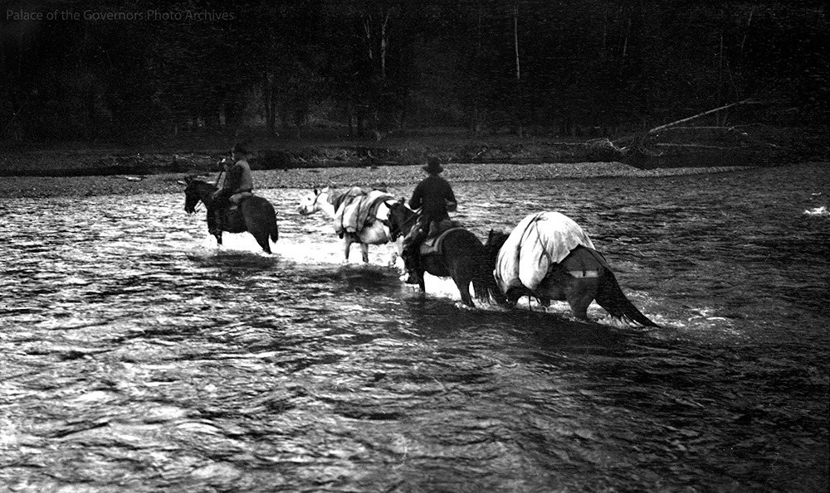

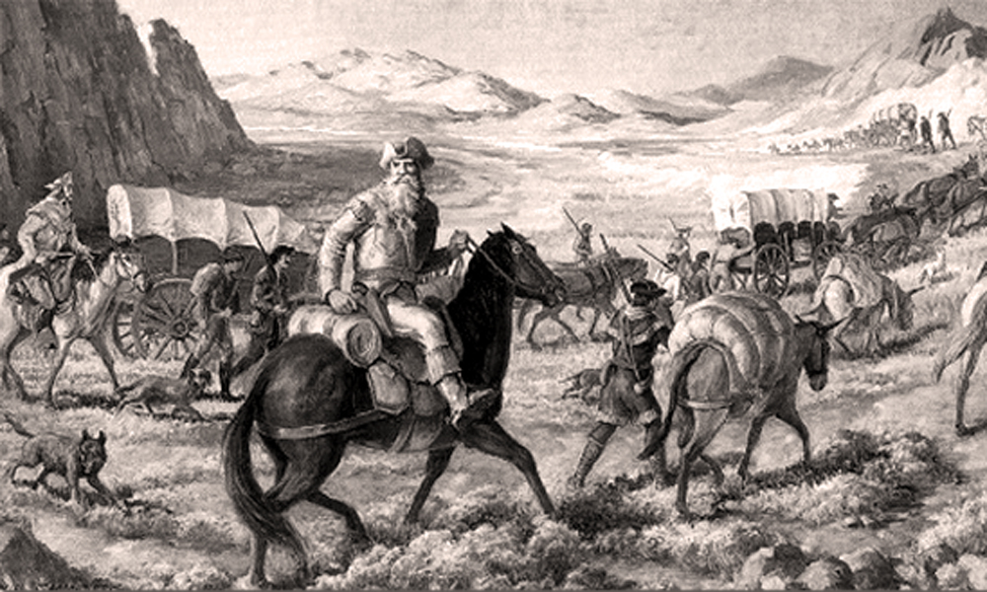

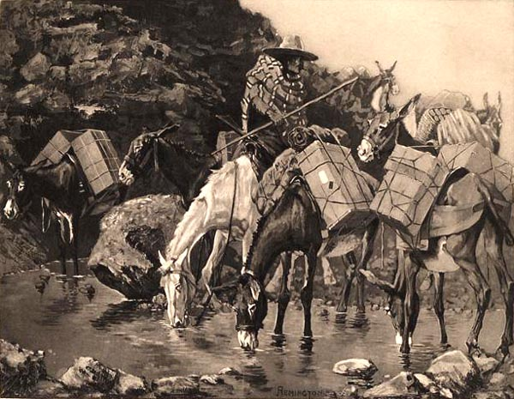

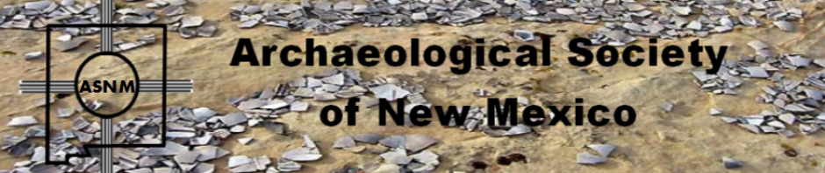

Budget information for 2020 for the Taos Archaeological Society is now posted on the website.

2021 Membership Dues can be paid now!!!!

The Taos Archaeological Society is offering Lifetime Membership with the contribution of $500.00 per individual anytime up until December 31, 2020. Take advantage of this Tax Deductible opportunity and help TAS fund our mission!! The Lifetime Membership will include the Member plus 1 additional family member.
TAS
PO Box 143
Taos, NM 87571

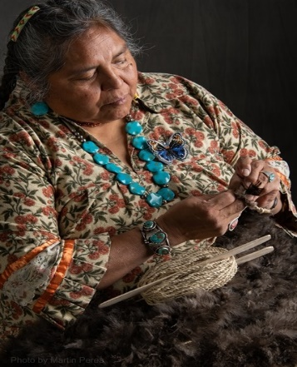
THIS ACTIVITY Has Been Rescheduled for JUNE 11, 2022
Members already paid are signed up!!!

To the Membership of the Taos Archaeological Society,

On Saturday, June 11, 2022, Mary Motah will conduct a basket and sandal weaving demonstration and hands on workshop for TAS members. The workshop will take place at the Kit Carson Board Room on Cruz Alta Road from 10am-4pm.

The participation is limited to 15 persons. This will fill quickly. Registration based on first 15 payments received. Please include your email to receive a confirmation.

If you miss out we will do this in an ongoing basis. The second 15 payments received will be confirmed to participate in the June 2023 workshop.

The participation fee is $15.00 check or money order made out to Mary Motah. It should be mailed to

Phil Alldritt
PO Box 659
Arroyo Hondo, NM 87513

First 15 deposits received are confirmed. No one is confirmed until payment is received.

Participants should bring a small pocket knife, wear shorts, bring brownbag lunch and drink.

In case of cancellation and you request a refund contact me here.

Thank you for your support and participation in the TAS activities!!

STAND BY FOR UPDATES FOR
SUMMER POT LUCK

TAKING RESERVATIONS FOR SUMMER 2021!!!!!
The Taos Archaeological Society is Funding trips for students to The Mesa Prieta Petroglyph Project!! Trips coming up in Spring 2022!!! COVID PERMITTING!!!
Contact Phil Alldritt at taoscuba@hotmail.com

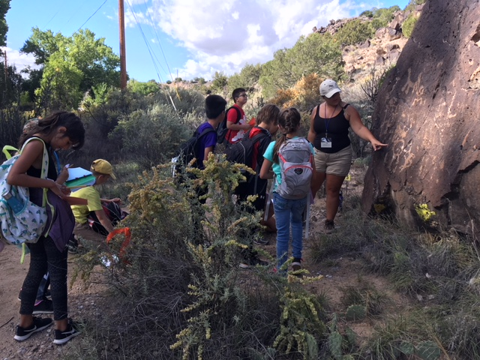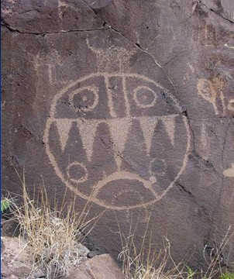

TAS is looking for Members to form an Education Committee who will promote and facilitate communication with teachers and schools to advance our bus trip programs!! To participate in this very successful effort contact Phil Alldritt at taoscuba@hotmail.com
Thank you!!!

Upcoming Trips
Trip reservations are first come first serve all trips have limited space. No reservation is confirmed until deposits have been made. Watch for future trips on the website!!!
Thank you! COVID PERMITTING!!!
All TAS trips may be sign up for by TAS Members who are Active Members in Good Standing. Persons wanting to participate should become Members by mailing 30.00 to
TAS PO Box 143 Taos, NM 87571 Thank you!!!\
Next Speaker
April 13, 2021
Karen Clary

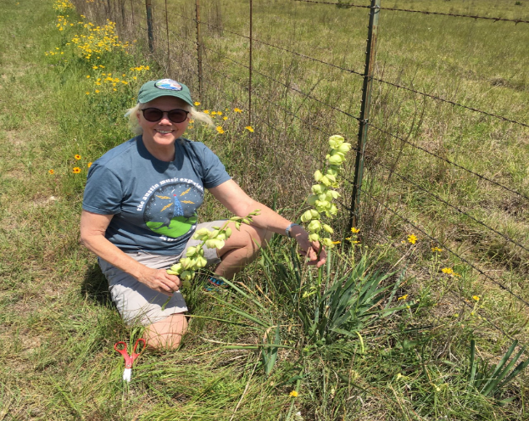

Back in 1978, Karen co-founded the Castetter Laboratory for Ethnobotanical Studies at UNM with Mollie Struever Toll and Anne Calvert Cully. The lab undertook ethnobotanical analyses of plant remains from archeological sites all over New Mexico, mostly for the OCA at UNM and the Lab of Anthroplogy in Santa Fe. In 1988, Karen moved to Texas and got a Ph.D. in Botany from the University of Texas where she studied taxonomy and biogeography of the Yucca species, which, by the way, are only native to the new world. She spent the rest of her career working on plant and natural resource conservation and retired in 2017 from the Lady Bird Johnson Wildflower Center, Austin, as Director of the Plant Conservation Program. She now volunteers as a lecturer for a variety of plant classes at the Wildflower Center, including general taxonomy, ethnobotany and economic botany. This year she also joined the IUCN species Red List Team to assess extinction threats for Yucca species.
Topic
The title of my talk is "The food the Ancient Chaco People ate - what the archeological record does and does not tell us," I will talk about how archeobotanists get plant remains from dirt at archeological sites and the ethnobotanical record we mine to connect plant remains found in sites to ancient lifeways, among other things, with a focus on the San Juan Basin.

Exciting speakers coming all next year 2021!!!! Watch for the bulletins online at taosarch.org for announcements!!!!

.

.

