The Taos Archaeological Society
April 9, 2019

_{Jim Boone}
_{UNM}
We Have Always Lived in a Castle: A Deep history of House and Hearth
Jim Boone grew up in the country outside College Station, Texas and spent a lot of time outdoors. He majored in English and Anthropology at UT Austin, and went to graduate school in Anthropology and Archaeology at Binghamton University in New York. Most of his archaeological field work has been in the late Roman and Medieval period of the western Mediterranean, including Morocco, Spain and Portugal. He has taught in the Anthropology Department at the University of New Mexico since 1987. He recently published a book on the Islamic period in Spain entitled Lost Civilization: the Contested Islamic past in Spain and Portugal (London: Duckworth).

Topic
Houses are such a ubiquitous feature of our modern world that it is easy to forget how distinctive and central houses are to human life. Elaborate, monumental houses start to appear in the archaeological record almost as soon as people begin to settle down and form permanent settlements at the end of the last Ice Age. In this lecture, I will talk about how and why it is our houses that make us distinctively human, rather than our supposed superior intellect. I will trace the development of House and Hearth from Paleolithic times to the present, using examples from the Neolithic Near East and Europe, the Pacific Northwest and the American Southwest.
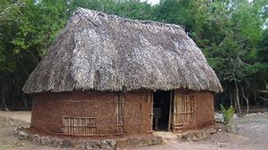

Taos Archaeological Society Book Club 2018-2019

7. April 18, Judith Hetem, We Are Dancing for You: Native Feminisms and the Revitalization of Women’s Coming-of-Age Ceremonies (Indigenous Confluences), Cutcha Risling Baldy, University of Washington Press (2018).
8. May 16, Group Potluck for selection of next year’s books. TBD
Reminders for Book Club will be sent out one week before each meeting.

Pot Creek Ceramic Sorting is still requesting volunteers to participate in processing out their Prehistoric collections. Wednesdays at 9:00am at the SMU Laboratory. Contact Mark Henderson for more information. markscotthenderson@gmail.com

Budget information for 2018 for the Taos Archaeological Society is now posted on the website.

The Taos Archaeological Society is offering Lifetime Membership with the contribution of $500.00 per individual anytime up until December 31, 2019. Take advantage of this Tax Deductible opportunity and help TAS fund our mission!! The Lifetime Membership will include the Member plus 1 additional family member.

TAS
PO Box 143
Taos, NM 87571

The Taos Archaeological Society, in cooperation with Carson National Forest will participate in archaeological testing of a rockshelter site in Valle Vidal this Summer of 2019. We will be posting updated information soon to Members.

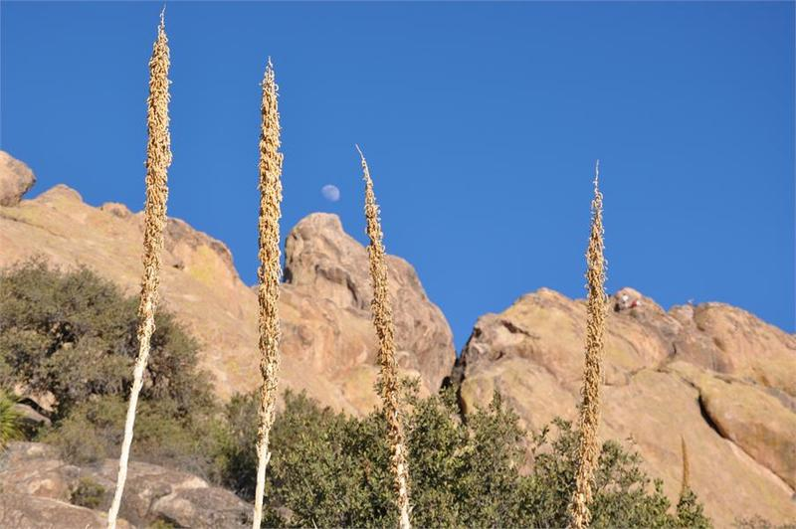

Summer POT LUCK
COMING SOON!!!
July 21, 2019

Home of Lewis Rosenthal and Diana Rushing
1517 Weimer Road
500pm-700pm
Bring your favorite Summertime Dish to Share!!!

Summer Lecture July 31, 2019
Kit Carson Board Room
6:30pm-8:30pm
Catrina Whitley and the Crew from Baahku will present findings from their ongoing excavations in Arroyo Seco.

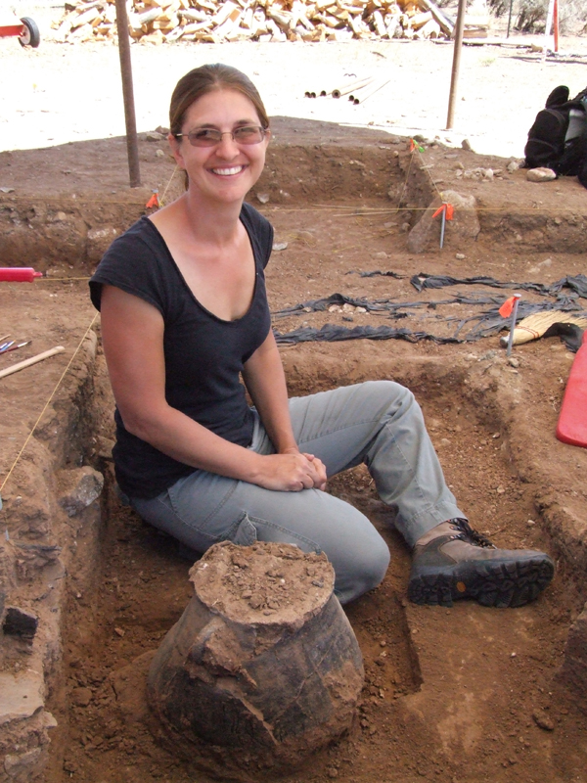

The Taos Archaeological Society is in part Funding trips for students to The Mesa Prieta Petroglyph Project!! Trips coming up this Spring!!
Contact Chris Riveles for information. ckriveles@gmail.com

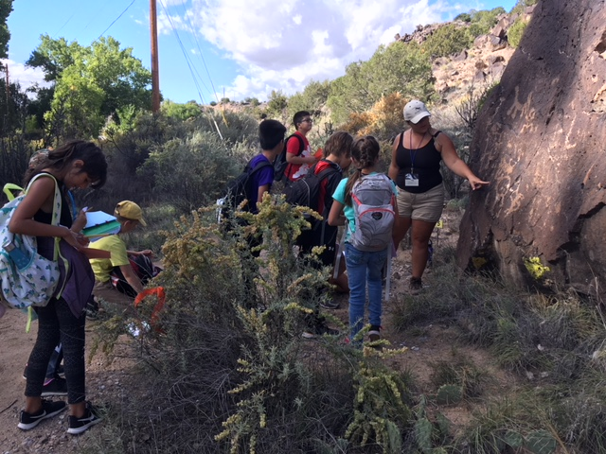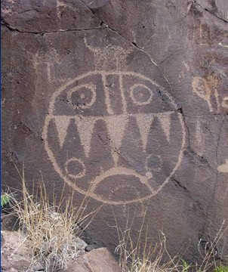

TAS is looking for Members to form an Education Committee who will promote and facilitate communication with teachers and schools to advance our bus trip programs!! To participate in this very successful effort contact Phil Alldritt at taoscuba@hotmail.com
Thank you!!!

TAS is also looking for Members to participate in organizing TAS archives from 2000-Present. We are requesting that any Members who have photographs from TAS trips and any archival materials to contact Phil Alldritt at taoscuba@hotmail.com. Thank you!!!!!

Upcoming Trips
Trip reservations are first come first serve all trips have limited space. No reservation is confirmed until deposits have been made.
Thank you!
All TAS trips may be sign up for by TAS Members who are Active Members in Good Standing. Persons wanting to participate should become Members by mailing 30.00 to
TAS PO Box 143 Taos, NM 87571 Thank you!!

Chaco Canyon Tour
Archaeologist Paul Reed
May 3-5, 2019 Sign up towerkiva@yahoo.com
$55.00 plus entrance fees.
Camping now CLOSED. Drive in participation only.

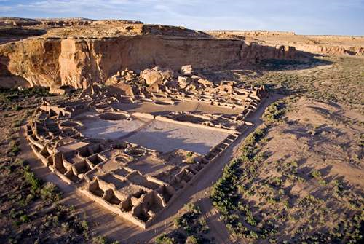

Ortiz Mining District Day trip to Santa Fe
June 1, 2019 15 person limit
High Clearance Required
Contact Phil Alldritt taoscuba@hotmail.com

10.00 Participation Fee SOLD OUT

Visit Waldo Coke Ovens, Museum in Cerrillos, Madrid, Golden Gold Mining Placer Fields
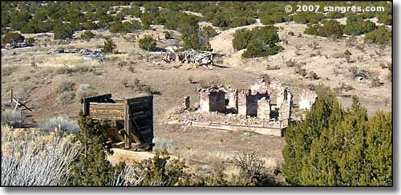
Golden, New Mexico

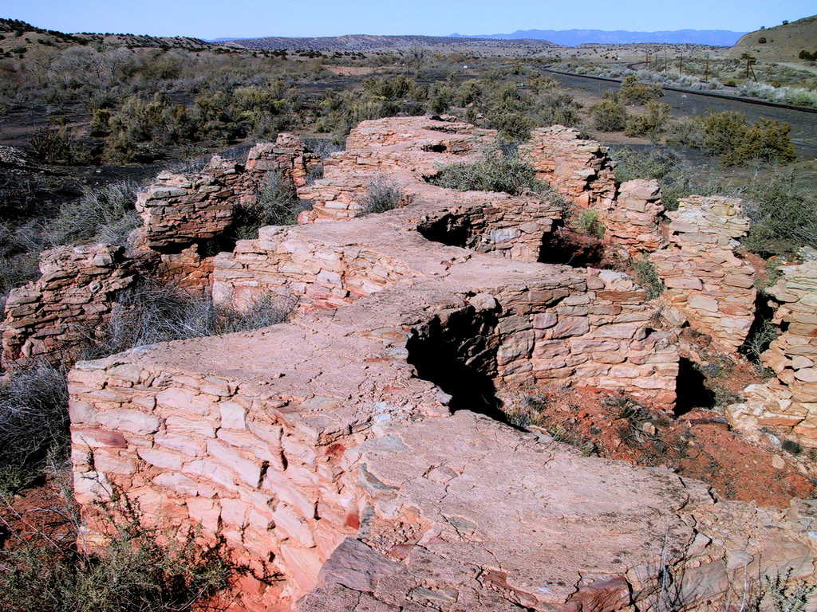
Waldo Coke Ovens

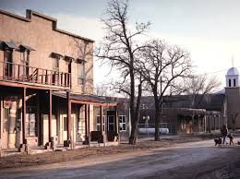
Cerrillos, New Mexico

Cuba: Historic Architecture, Archaeology, Art and Culture
100% LEGAL with Documents
May 14-22, 2019
January 10-19, 2020
First deposits of $500.00 per person received will be confirmed.

10 spots remaining
See itinerary on TAS website.
Contact Phil Alldritt
taoscuba@hotmail.com

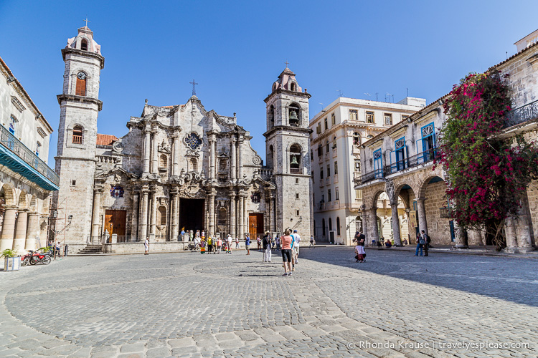

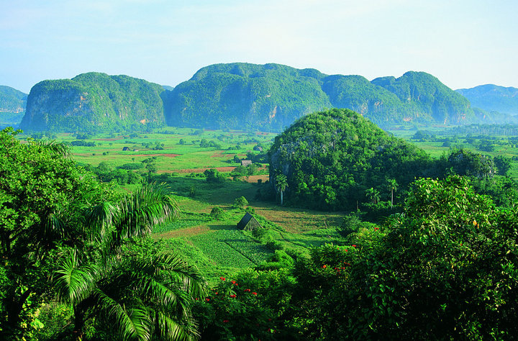

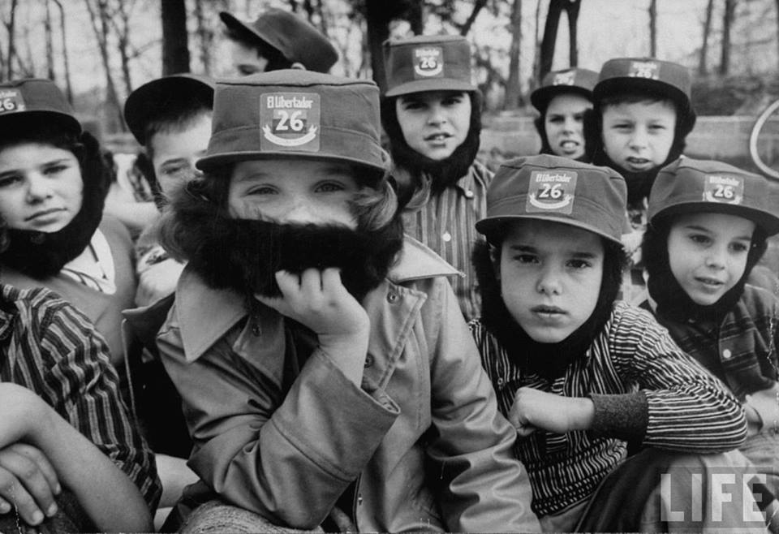

Mayan Sites of Chiapas, Mexico
February 18-27, 2020
12 spaces available
Contact Phil Alldritt
taoscuba@hotmail.com to sign up
.
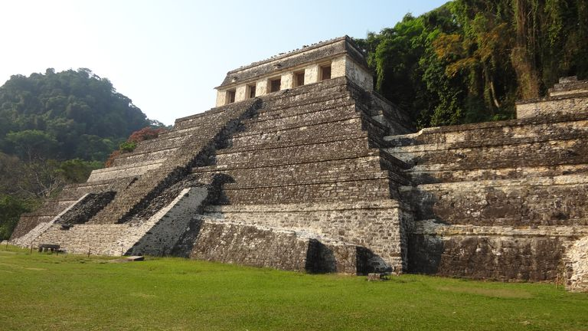
Temple of the Inscriptions Palenque

Mayan Archaeology, World Class Birdwatching, Hiking, Boat trips, and Natural History with Professional Guides.
We Visit Palenque, Bonampak,Yaxchilan, Tonina, Tortuguero, Olmec Museum
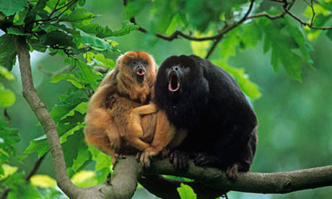
Black Howler Monkeys

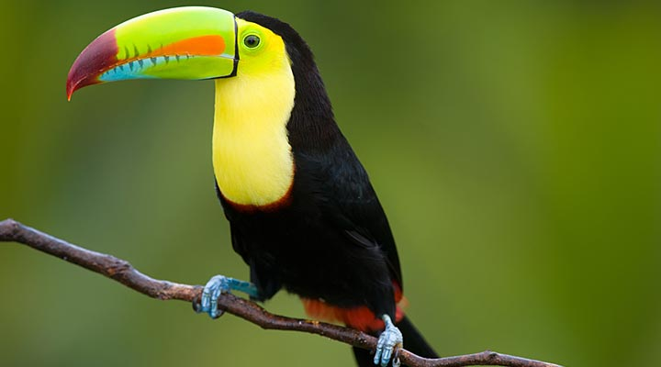
Keel-Billed Toucan

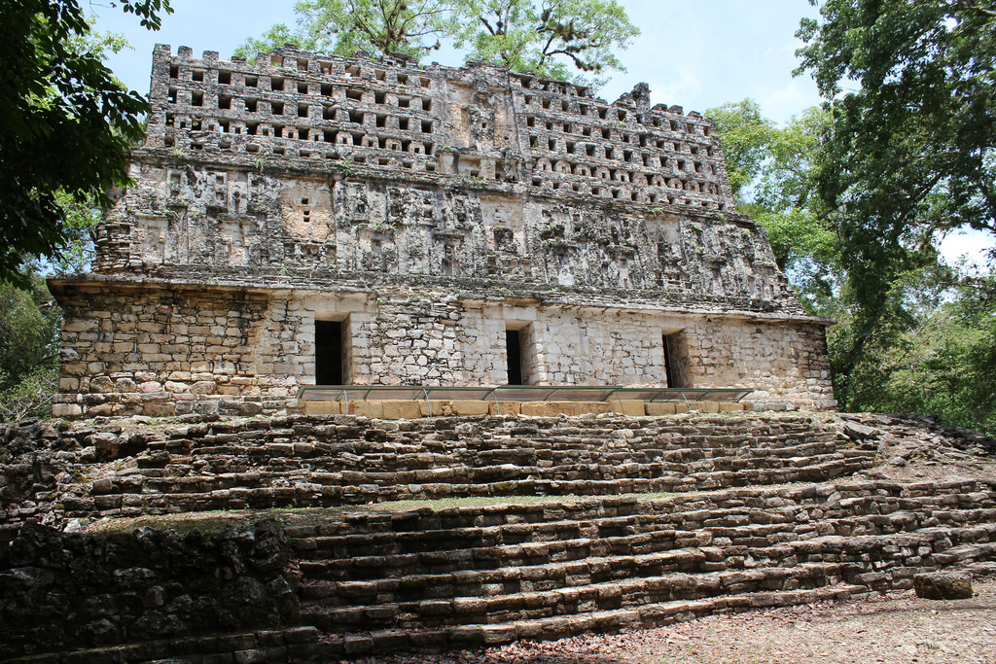
Temple 33 Yaxchilan

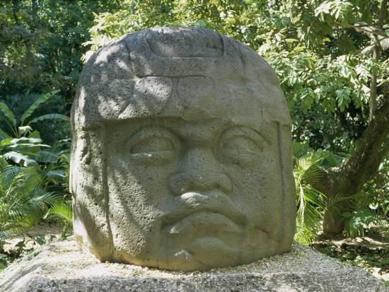
Giant Olmec Head

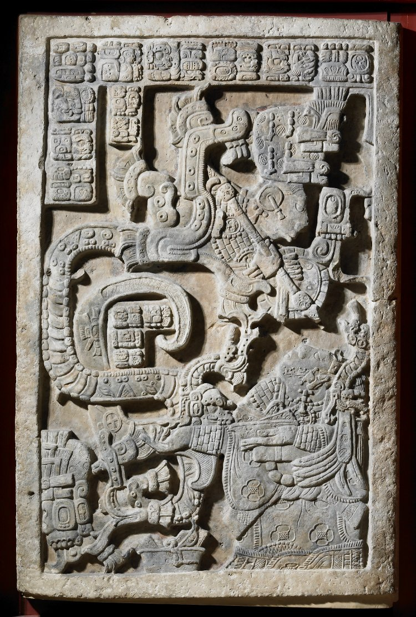

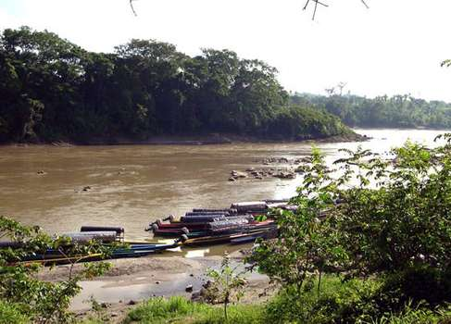

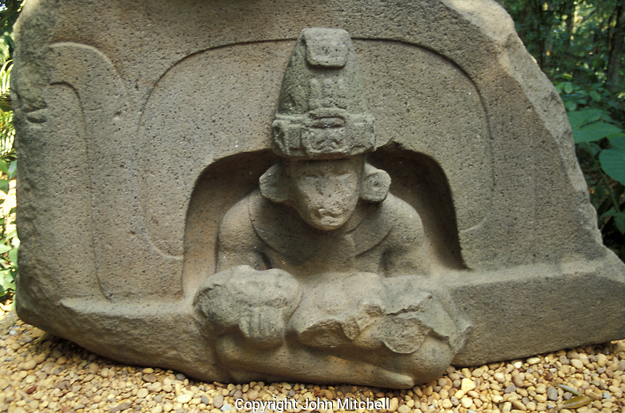
Olmec Museum Villahermosa, Tabasco
Belize
Chan Chich
February 4-13, 2020
Mayan Archaeology, Birdwatching, River Trip, Ecolodge Snorkeling 8 persons max 8 spots remaining Contact:taoscuba@hotmail.com 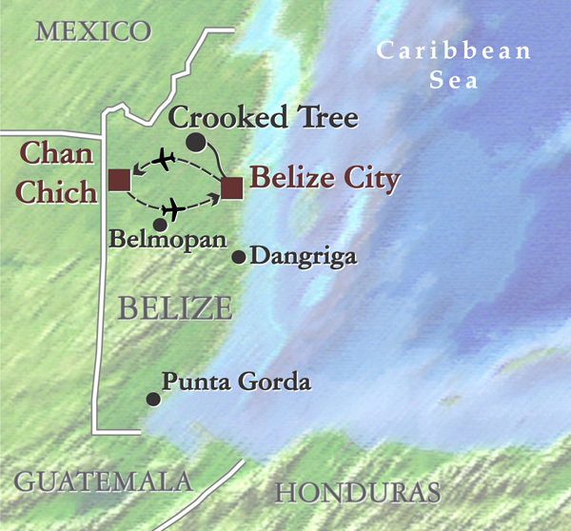

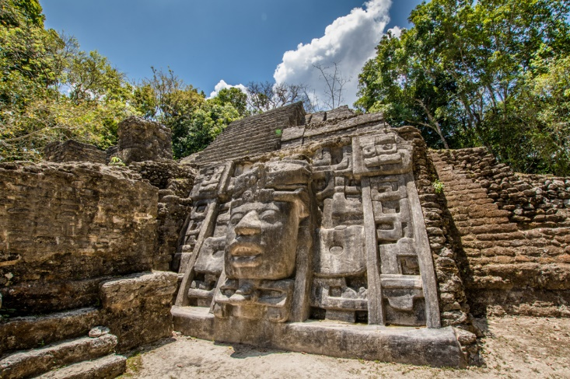

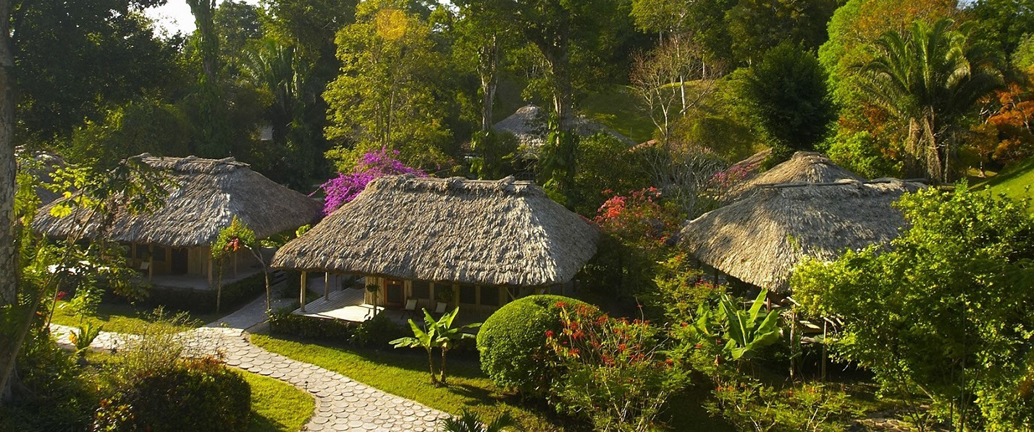

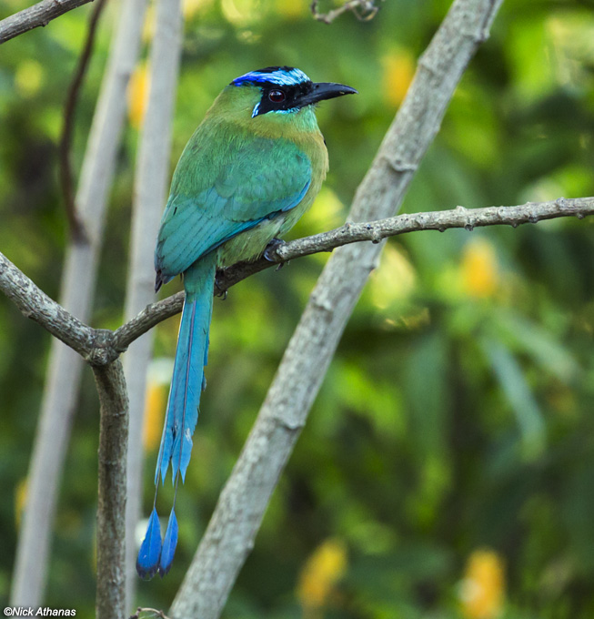

Turquoise Browed Mot Mot
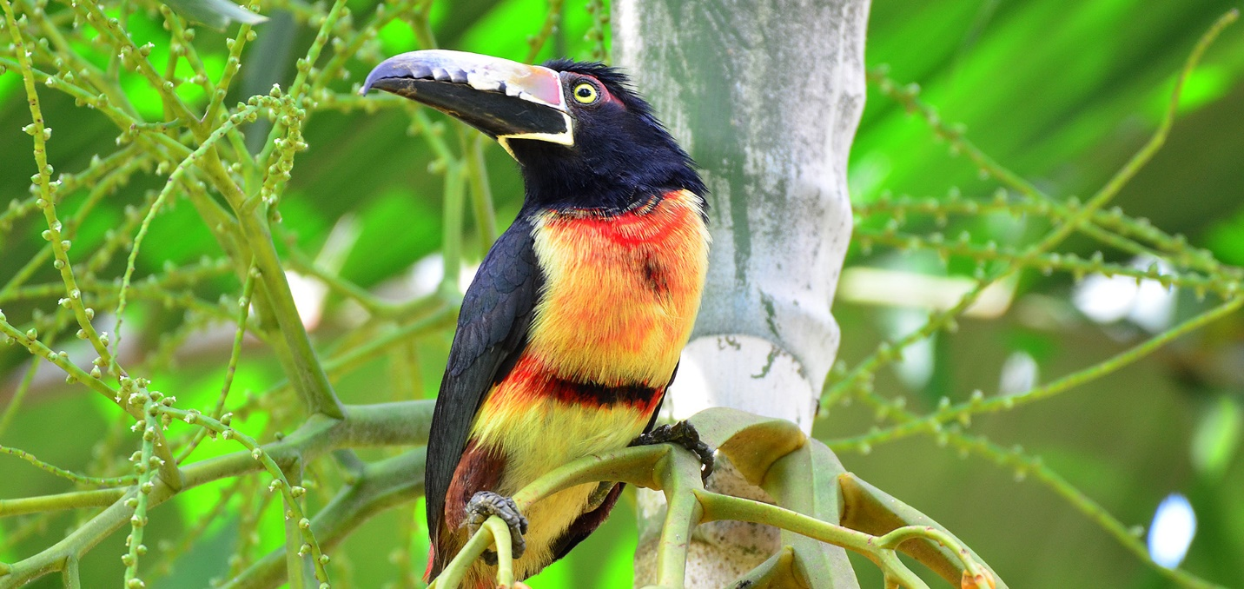
Collared Aracari

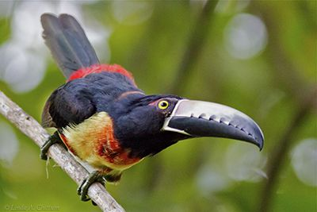

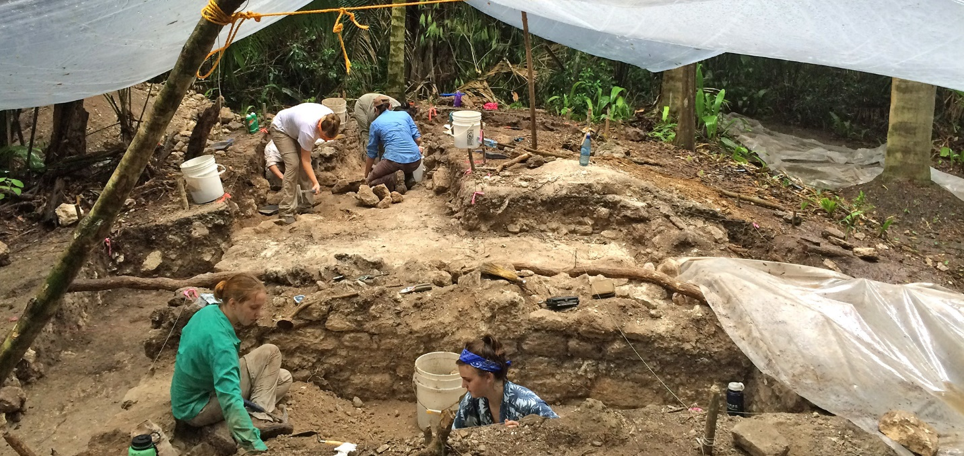

Ruins of Chan Chich

Birdwatching Platform

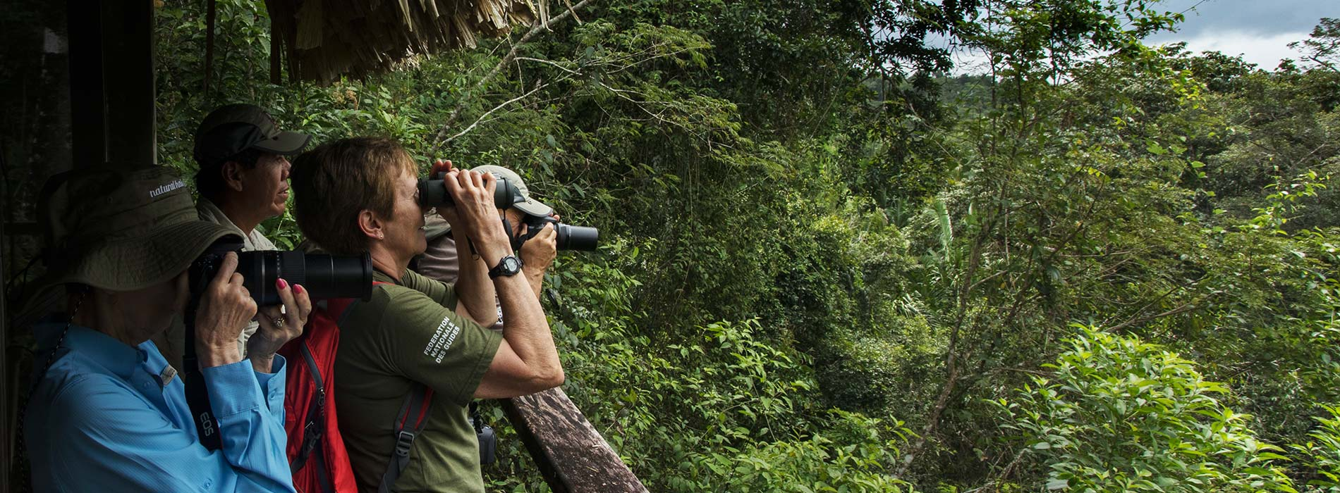

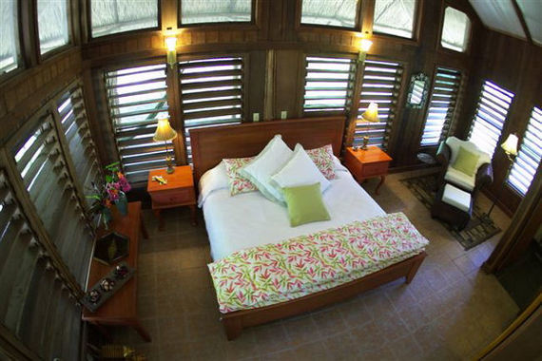

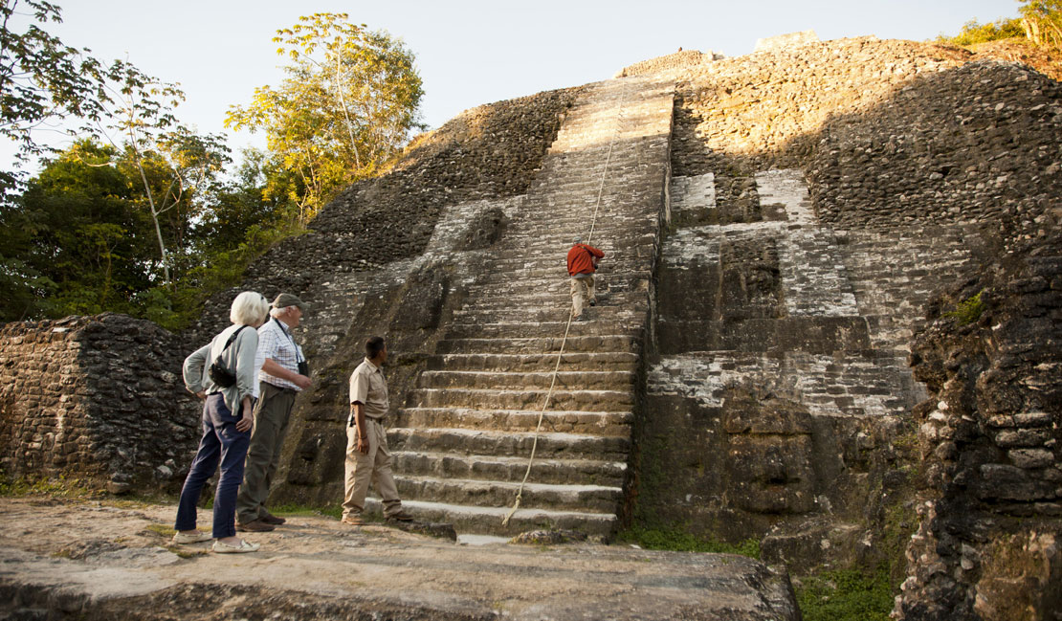

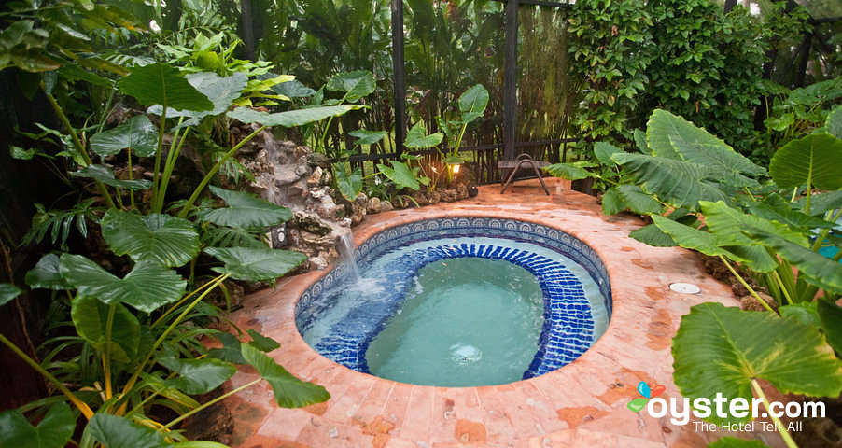

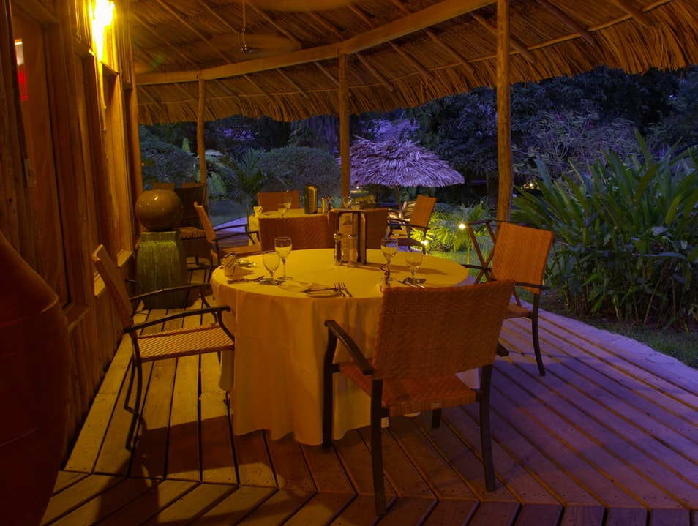
Next Speaker Tuesday May 7, 2019
_{Dave Greenwald}
_{ARCHAEOLOGIST Project Director}
Creekside Site Tularosa, New Mexico

Topic
Excavations at the Creekside Archaeological Site in Tularosa, New Mexico are discussed.



